User Manual
for
Irrigation Demand
Estimation Tool
(IDE Tool)
(Version 1.3)

February 2019

Prepared for:
The City of Calgary

Prepared by:
Dillon Consulting Limited

#200, 334 – 11 Ave. S.E.
Calgary, AB T2G 0Y2

IDE Tool – Version History

IDE Tool V1.0 (January 2015) The beta version of the IDE Tool.

IDE Tool V1.1 (May 2015) Draft user manual and IDE Tool submitted to the City of Calgary for review.

IDE Tool V1.2 (May 2016) User manual revisions and corrections to IDE Tool.

IDE Tool V1.3 (January 2017) User manual revisions and corrections to IDE Tool.

IDE Tool V1.3 (February 2019) Minor formatting updates only – no changes to content.

Copyright and Disclaimer

Welcome to the Irrigation Demand Estimation Tool (IDE Tool) for The City of Calgary.

The IDE Tool and this User Manual were prepared by Dillon Consulting Limited (Dillon) on behalf of The City of Calgary. All copyright and trademarks on the IDE Tool and associated materials remain the property of The City of Calgary.

If you continue to browse and use the IDE Tool you are agreeing to comply with and be bound by the following terms and conditions of use:
- Neither The City of Calgary nor Dillon provide any warranty or guarantee as to the accuracy, performance, completeness or suitability of the IDE Tool and associated materials for any particular purpose. You acknowledge that the IDE Tool and associated materials may contain inaccuracies or errors and The City of Calgary and Dillon exclude liability for any such inaccuracies or errors.
- Your use of the IDE Tool and associated materials is entirely at your own risk, for which The City of Calgary and Dillon will not be liable. The City of Calgary and Dillon are not responsible for any liability for any direct, indirect, incidental, consequential or other damages resulting from the use, misuse or misinterpretation of the IDE Tool and associated materials.
- You agree that it is your responsibility to ensure that the IDE Tool and associated materials meet your specific requirements. You agree to ensure that the analysis and design, and subsequent performance of project sites meet all relevant watershed targets, standards and guidelines. You agree to consult a Stormwater Professional and Irrigation Specialist before utilizing the IDE Tool and associated materials.
- Every reasonable effort has been made to have the IDE Tool run smoothly on typical hardware. However, neither The City of Calgary nor Dillon take any responsibility for, and will not be liable for, the IDE Tool not being able to be applied due to technical issues beyond our control.
- You agree to immediately advise The City of Calgary of any issues that arise out of the use of the IDE Tool and associated materials. You understand that the IDE Tool and associated materials are subject to change without notice and that updates of the IDE Tool will be posted on The City of Calgary’s website (Click Here).

TABLE OF CONTENTS
Page
1 INTRODUCTION 1
1.1 Using This Manual 1
1.1.1 User Background 1
1.1.2 Organization of the IDE Tool Manual 1
1.2 Background 2
1.3 Overview of Capabilities 2
1.4 Limitations and Scope 4
2 TECHNICAL OVERVIEW 6
2.1 Precipitation 7
2.2 Temperature 7
2.3 Soil Texture and Hydraulic Properties 7
2.4 Effective Precipitation 8
2.5 Evapotranspiration 8
2.6 Landscape Coefficient Method 9
2.7 Water Stress Factor 10
2.8 Irrigation Losses 12
2.9 Irrigation System Management Efficiency 14
2.10 Irrigation Scheduling 14
2.11 IDE Tool Outputs 15
2.12 Summary of Assumptions and Daily Calculations 15
3 PREPARING TO LAUNCH THE IDE TOOL 18
3.1 Obtaining the Latest Version 18
3.2 Excel Requirements 18
3.3 Microsoft® Excel Macro Settings 18
3.4 Hardware Requirements 19
3.5 Terminology 19
4 LAUNCHING THE IDE TOOL 20
5 USING THE IDE TOOL 22
5.1 IDE Tool Organization 22
5.2 Data Entry and Viewing 23
5.3 Project Information 23
5.3.1 Project Data 23
5.3.2 Main Settings 24
5.3.3 Custom Settings 26
5.3.4 Area Settings 27
5.4 Initiating Analysis 32
5.5 Results 33
5.6 Results - Calculations 34
5.6.1 Calculations Worksheet 34
5.7 Results - Worksheets 36
5.7.1 Calculations Summary Worksheet 36
5.7.2 Irrigation Results Worksheet 36
5.7.3 Irrigation Summary Worksheet 37
5.7.4 Water Balance Results Worksheet 37
5.8 Results - Charts 38
5.8.1 Water Balance Chart 38
5.8.2 Annual Irrigation Chart 39
5.8.3 Monthly Irrigation Chart 40
5.8.4 Monthly Irrigation Histogram Chart 41
5.9 Outputs 42
5.9.1 SWMM Source Withdrawal Time Series 42
5.9.2 SWMM Combined Precipitation and Applied Irrigation File 43
5.9.3 WBSCC Input 43
5.9.4 PDF Summary Output 43
6 References 44

TABLES

Table 1: Species Factor (K_{PS}) for Different Vegetation Types 9
Table 2: Density Factor (K_{D}) for Different Vegetation Types 9
Table 3: Microclimate Factor (K_{MC}) for Different Vegetation Types 10
Table 4: Example Water Losses for Different Sprinkler Types 13
Table 5: “Main Settings” Worksheet Entries 24
Table 6: Custom Entry Data Fields 26
Table 7: Area Setting Worksheet –Area Determination Method 28
Table 8: Area Settings Worksheet Values 31

FIGURES

Figure 1: Water Stress Coefficient, K_{S} (Allen, et al., 1998) 11
Figure 2: Irrigation Water Losses (Rogers et al., 1997) 12
Figure 3: The IDE Tool Instruction Screen for Enabling Macros 18
Figure 4: Required IDE Tool Macro Settings (Microsoft® Excel 2010) 19
Figure 5: Macro-enabled Start Screen 20
Figure 6: Terms and Conditions Page 21
Figure 7: IDE Tool Selection Window 21
Figure 8: The IDE Tool Organization 22
Figure 9: Project Data Worksheet 24
Figure 10: Main Settings Worksheet 25
Figure 11: Custom Entries Access from the Main Settings Worksheet 25
Figure 12: Custom Entries Editor 27
Figure 13: Area Determination by Summation 28
Figure 14: Area Determination by Definition (Prior to Clicking ‘Adjust Total’) 28
Figure 15: Area Determination by Definition (After Clicking ‘Adjust Total’) 29
Figure 16: Area Settings Worksheet – Example Pop-up Window 30
Figure 17: Area Settings Worksheet (Definition Method) 31
Figure 18: Example of an Invalid Entry and Failed Validation 32
Figure 19: Calculation Progress Screen 32
Figure 20: Locked Main Settings Worksheet 33
Figure 21: Locked Area Settings Worksheet 34
Figure 22: Dropdown to Select Which Area’s Calculations Are Displayed 34
Figure 23: Irrigation Results Worksheet Example 36
Figure 24: Irrigation Summary Worksheet Example 37
Figure 25: Water Balance Results Worksheet Example 38
Figure 26: Water Balance Graph Example 39
Figure 27: Annual Irrigation Chart Example 40
Figure 28: Monthly Irrigation Chart Example 41
Figure 29: Monthly Irrigation Histogram Example 42
Figure 30: Combined Precipitation and Applied Irrigation File Format 43

APPENDICES

Appendix A IDE Tool Sample PDF Output and Sample Time Series Output Files
Appendix B Glossary
Appendix C List of Abbreviations

INTRODUCTION
Welcome to the Irrigation Demand Estimation Tool (IDE Tool) for The City of Calgary.

The purpose of the IDE Tool is to enable users to:
- Simulate the irrigation water demand of specific plant species within soil masses consisting of a single homogenous soil texture classification;
- Output these results for use in continuous (1960 – 2014) stormwater management modelling (SWMM) by producing:
  - An hourly time series to represent stormwater withdrawal from a single source (i.e., stormwater pond or cistern) for the purposes of reuse (i.e., irrigation); and
  - A combined hourly applied irrigation and City of Calgary precipitation file in the “Digital Archive of Canadian Climatological Data (Surface) Identified By Element” hourly format.
- Produce tables for Crop Water Requirements and Weekly Watering Schedule for input into The City of Calgary’s Water Balance Spreadsheet (WBSCC); and
- Produce standardized documentation of the irrigation demand simulation process in order to facilitate review by The City of Calgary.

Using This Manual

User Background
This manual is intended for users with a working knowledge of plant water demands, soil moisture content, irrigation systems, and stormwater management principles and modelling. It is also recommended that users of this manual and the IDE Tool be proficient with Microsoft® Excel.

Organization of the IDE Tool Manual
The IDE Tool Manual is sub-divided into the following sections:
Section 1 Introduction, Capabilities and Limitations of the IDE Tool
Section 2 Technical Overview
Section 3 Preparing to Launch the IDE Tool
Section 4 Launching the IDE Tool
Section 5 Using the IDE Tool
References
Appendix A IDE Tool Sample Output Package
Appendix B Glossary
Appendix C List of Abbreviations

Background
The City of Calgary Water Resources Business Unit (“The City”) identified a need for a tool to estimate irrigation demand for the purposes of stormwater reuse. The IDE Tool was developed to meet this need and target consistency in stormwater management (SWM) modelling assumptions for stormwater reuse and irrigation computations. The IDE Tool is consistent with the approaches typically utilized in irrigation analysis and design practice.

Results generated by the IDE Tool can be integrated with other modelling platforms (e.g., XP-SWMM, EPA SWMM, PC-SWMM, etc.) to demonstrate that a proposed development or redevelopment can meet City runoff volume targets. Summary results from the IDE Tool may also be used as input to the Water Balance Spreadsheet for The City of Calgary (WBSCC).

Additionally, the use of a consistent tool will enable The City Water Resources Development Approvals team to streamline the review of consultant submissions.

The IDE Tool provides justifiable estimates of water volumes required as part of a stormwater reuse system intended for irrigation. The analysis within the IDE Tool considers many factors including:
- topsoil characteristics (e.g., type, depth and compaction);
- subsoil characteristics;
- plant cover species;
- water holding capacities;
- Landscape evapotranspiration (ET_{L});
- temporal variability of water demands;
- precipitation patterns;
- antecedent moisture conditions;
- equipment efficiencies;
- irrigation system management efficiencies; and
- other environmental factors (such as a reduction in ET_{L} when the soil water content (SWC) is below the amount that is easily extracted from plants for purposes of transpiration).

Overview of Capabilities
The IDE Tool has been developed for The City using macro-enabled Microsoft® Excel 2010 and performs a semi-continuous (i.e., using 55 years of data but only for the months of May through September) simulation on a daily time step using factors such as precipitation, effective precipitation, temperature, reference and landscape evapotranspiration (based on the Landscape Coefficient Method) and wind speed. The simulation estimates the water demand (i.e., irrigation demand) for a defined plant species based on the soil texture, soil compaction, sub-soil characterization, rooting depth, density, and micro-climate.

Built-in Capabilities of the IDE Tool include:
- Users define up to 15 discrete irrigation areas being fed from a single irrigation source. The water demand characteristics of each area are based primarily on the size of the area, topsoil and subsoil types, topsoil compaction level, plant species, rooting depth, vegetation density, and localized environmental conditions (i.e., microclimate);
- Each of the up to 15 discrete irrigation areas is assumed to be comprised of a single vegetation species or turf mix with a predefined water demand. The IDE Tool includes the following built-in vegetation types (with reference to City of Calgary Park turf specifications), and also provides the facility to define custom types. (Low, medium and high denote the relative water demand for each species.)
  - 7 different specific turf types:
    - Cool season Turf - medium;
    - Urban A – low;
    - Urban B – low;
    - Urban C – medium;
    - Urban D – low;
    - Urban E – low; and
    - Urban F – low.
  - 12 different specific tree types:
    - Amur Maple – medium;
    - Burr Oak – medium;
    - Brandon Elm – medium;
    - Colorado Blue Spruce – medium;
    - Toba or Snowbird Hawthorn – medium;
    - Ivory Silk Tree Lilac – medium;
    - Pincherry – low;
    - Poplar – medium;
    - Scots pine – low;
    - Snow Mountain ash – low;
    - Siberian Larch – medium; and
    - Choke Cherry – medium.
  - 5 different shrub types:
    - Juniper – low;
    - Snowberry – low;
    - Cranberry – medium;
    - Lilac – medium; and
    - Mugo Pine – medium.
  - In addition to the specific species noted above, general species are also included:
    - Trees – low, medium and high;
    - Shrubs – low, medium and high;
    - Ground Cover – low, medium and high;
    - Mixed – low, medium and high; and
    - Turfgrass – low, medium and high.
  - User defined species. A user can define a custom species for use in the IDE Tool by specifying the vegetation type (tree, shrub, ground cover, mixed or turfgrass), the relative water demand (low, medium or high) and the Species Factor, K_{PS}.
- The total extent of the irrigated area can be defined in two different ways:
  - Summation - The user defines the extent of each individual area (in hectares) and the IDE Tool sums the individual areas to obtain the total area; or
  - Definition - The user directly defines the total area (in hectares) and provides only a relative size for each individual area (unitless). The extent of each individual area is pro-rated from the total area based on the relative areas defined.
- Actual historical climate data for the Calgary area is built into the IDE Tool and used in the simulation calculations. The data includes daily precipitation, minimum daily temperature, daily relative humidity, and mean daily wind speed;
- Daily reference evapotranspiration is estimated from historical climate data;
- Landscape evapotranspiration is estimated using the Landscape Coefficient Method (LCM) and an Water Stress Coefficient; and
- The IDE Tool simulates the water demand of all irrigation areas on a daily time step basis and generates results including summary statistics and two different types of hourly time series that can be used in Stormwater Management Modelling (SWMM).

Limitations and Scope
The IDE Tool is intended as a planning tool for stormwater reuse to help the consulting industry meet the runoff volume targets for new developments and redevelopments within the Calgary city limits.

The IDE Tool uses a “check book” method to estimate the volume of water required to maintain healthy plants during the irrigation season (i.e., May through September) using approaches and assumptions determined in co-operation with The City of Calgary’s Water Resources and Parks Business Units.

The methods followed by IDE Tool are not the only available approach to simulating the water demand of plants; however, it follows the irrigation volume procedures accepted by Calgary Parks.

Current limitations of the IDE Tool include:
- Plant water requirements are assumed to be satisfied by withdrawing water from a single source (i.e., one pond or one cistern);
- An individual irrigation area is considered to be homogeneous in terms of soil type, vegetation type, vegetation density and microclimate;
- Routing of runoff from one overall area to another is not simulated;
- The IDE Tool uses a daily time step. Runoff is calculated assuming that the maximum intensity of the rain event during the day in question is less than the infiltration rate of the soil (the actual maximum intensity during any given day is ignored by the IDE Tool);
- The plant growth is considered mature (i.e., full leaf development), healthy, and static;
- Assumes that climate data (i.e., precipitation, evapotranspiration, temperature and wind speed) as recorded at the Calgary International Airport is representative of any location within the Calgary city limits. The opportunity for a user-supplied adjustment factor is provided to increase or decrease the precipitation values for a specific location, but any such adjustment should be well-supported by historical data.
- The IDE Tool is a hydrologic planning tool that is intended to estimate the daily irrigation volumes in support of Staged Master Drainage Plans, Pond Reports and Stormwater Management Reports. It is NOT intended for the detailed design of the irrigation distribution system. An irrigation design professional shall be consulted for the latter.
- The IDE Tool simulates the irrigation demand annually for the months of May through September. The winter months (i.e., October through April) are skipped as the IDE Tool is not currently capable of estimating the changes to the soil water content during the winter months. The water content is assumed to be at Field Capacity on May 1st of each year.
In order to maintain the consistency of water balance calculations, the difference in volume between the estimated water content at the end of an irrigation season and the assumed content at the start of the following irrigation season is reported as “Added Water Content”.

TECHNICAL OVERVIEW
To assess the soil water content (SWC) for irrigated areas, the IDE Tool estimates evapotranspiration based on the Landscape Coefficient Method and if necessary, determines the volume of water required to return the soil-water column to a target level related to the field capacity (FC) of the soil. The soil water content budgeting also takes into consideration the amount of water lost to deep percolation (i.e., occurring when the soil water content > field capacity) and to surface runoff (i.e., occurring when the soil water content > saturation). Irrigation is further controlled by scheduling rules and other requirements.
Within the IDE Tool, SWC is represented as the effective depth of the water column within the rooting zone at the beginning and end of each day of the irrigation season (i.e., May through September). This depth is converted to volume using the plan extent of each individual area. The volume results are provided for each area individually as well as for the total area; the depth results are provided for the individual areas only.
The irrigation demand from May 1st through September 30th of each year is computed based on a daily accounting of the soil moisture water balance using historic climate data and estimated evapotranspiration for the different plant species, vegetation density, microclimate, and water stress.

The volumetric SWC budget is computed on a daily time step:

EWC = IWC + P_{DE} + I_{DN} - ET_{L} - DP - R (1)

Where: EWC = Current day ending soil water content (mm)
IWC = Current day starting soil water content (= EWC_{PREV}, previous day ending soil water content) (mm)
P_{DE} = Daily effective precipitation (mm)
I_{DN} = Daily net irrigation (mm)
ET_{L} = Estimated actual evapotranspiration (mm)
DP = Deep percolation (mm)
R = Runoff (mm)

SWC is a function of the above inputs/outputs and the soil water holding characteristics of a specific soil (i.e., saturation, field capacity, wilting point, rooting depth, saturated hydraulic conductivity).

The demand volume of irrigation water (V_{DEMAND}) is determined by multiplying the daily net irrigation depth (mm) by the area to be irrigated:

V_{DEMAND} = I_{DN} * Area (2)

The demand volume considers only the actual demand of the vegetation. Other factors such as the efficiency of the irrigation system will affect the volume of water that is required to meet this demand. This is discussed in a later section of this manual.

Precipitation
Daily total precipitation data included in the IDE Tool is based on values from the Environment Canada Weather Office database for the period 1960-2014 for Station 3031093 – Calgary International Airport, Calgary, Alberta. Total precipitation is defined by Environment Canada as the sum of the total rainfall and the water equivalent of the total snowfall observed during each day of the record. The IDE Tool conservatively assumes that all precipitation for the months of May through September falls as rain, and thus enters the soil water column the same day in which it occurs. The values included in the IDE Tool are not taken directly from the Environment Canada database; The City provided a set of values for inclusion that are based on the Environment Canada data but with some minor adjustments and corrections to account for missing readings and other similar issues. This dataset is identical to the one that is posted on The City's website, and which The City wants the consulting industry to use for stormwater management planning and design purposes.

Temperature
The IDE Tool uses hourly air temperature (°C) as measured at the Calgary International Airport (Station 3031093), Calgary, Alberta, and provided by The City of Calgary Water Resources for the period 1960-2014. The air temperature data is also used to calculate reference evapotranspiration (see Section 2.5) and to determine if irrigation can occur during the scheduled day and time.

Soil Texture and Hydraulic Properties
The soil hydraulic properties used by the IDE Tool are dependent on the soil’s texture. The soil texture is the weighted distribution of the main particles comprising the soil (i.e., clay, sand, and silt). The distribution of these particles affects a number of soil characteristics including hydraulic conductivity, porosity, saturated water content, field capacity, and wilting point.
The soil characteristics in the IDE Tool define the hydraulic performance and water storage capacity within the rooting layer. The depth of the rooting layer, or rooting depth, is the soil depth from which the plants will draw its water requirement.

Soil types built into the IDE Tool use default parameters as suggested by the Green-Ampt analysis method. Other means of determining soil parameters include the use of external software such as the Soil-Plant-Air-Water (SPAW) software, which provides the user with the ability to make adjustments to the hydraulic properties of the soil based on particle distribution, organic matter, salinity, gravel content, and compaction. The compaction becomes important due to the impact on evapotranspiration as well as saturated hydraulic conductivity. When SPAW, or similar external software, is used to define the hydraulic properties of the soil, custom user-defined soil types are required.
The steps involved in estimating the hydraulic properties of soils using the SPAW software can be found in The City of Calgary’s User Manual for Water Balance Spreadsheet Version 1.2 (WBSCC), dated November 2011, which can be found on The City’s website (Westhoff, 2011).

Within the IDE Tool, the compaction level of the soil is used to estimate a reduction in bulk density, which is, in turn, used to adjust the water holding capacity of the soil column at saturation and at field capacity. The compaction levels and corresponding changes in bulk density are derived from the Soil Water Characteristics Tool in SPAW (Saxton, 2006).

The increase in bulk density assumed for the various compaction levels is as follows:

Compaction Level | Increase in Bulk Density
Uncompacted | 0%
Dense (Low) | 10%
Hard (Medium) | 20%
Severe (High) | 30%

Effective Precipitation
Daily effective precipitation (P_{DE}) is defined by the following equation (IABC, 2004; Farmwest):

P_{DE} = (P – Threshold) * 0.75 (3)

Only precipitation that exceeds the threshold value will contribute to the soil moisture. The efficiency factor is set to 0.75 by default but can be manipulated by the user on the Main Settings tab.

Evapotranspiration
Daily values for reference evapotranspiration (ET_{o}) were estimated using climate data obtained from Alberta Agriculture. The following equation was used to calculate reference ET on the Canadian Prairies (Maulé et. al, 2006):

ET_{o} = 0.077(T_{max} – T_{min}) + 0.114T + 0.832ΔR_{a} – 2.77e_{a} + 0.269u₂+ 0.053 (4)

The slope of the soil vapour curve (Δ), extraterrestrial radiation (R_{a}), and mean daily actual vapour pressure (e_{a}) were calculated using temperature and relative humidity data and the standard equations provided by ASCE (2005). Daily maximum air temperature (T_{max}), daily minimum air temperature (T_{min}), and mean daily wind speed at 2-m height (u₂) were obtained from the Calgary International Airport (Station 3031093).

Landscape evapotranspiration (ET_{L}) is estimated as a proportion of the ET_{o} using a Landscape Coefficient (K_{L}) and water stress factor (K_{S}) as follows:
ET_{L} = ET_{o} * K_{L} *K_{S} (5)

Elements of this equation are considered further in the following sections.

Landscape Coefficient Method
The Landscape Coefficient Method determines the estimated landscape evapotranspiration for a given type of vegetation species by combining factors based on the water demand of the species type (K_{PS}), planting density (K_{D}), and microclimate (K_{MC}). The water demand and planting density are rated as high, medium or low, while microclimate is rated as exposed, normal or shaded.

K_{L} = K_{PS}* K_{D}* K_{MC} (6)

The Species Factor (K_{PS}), see Table 1, refers to plant water requirements with high having a large water requirement and low having a small water requirement. The water requirement is determined by the specific plant species selected in the IDE Tool or as a user-defined entry. The Density Factor (K_{D}), see Table 2, refers to differences in water loss based on leaf surface area with the larger the leaf surface area, the higher the coefficient. The Microclimate Factor (K_{MC}), see Table 3, refers to the impact the physical surroundings have on evapotranspiration. Exposed microclimates offer more severe conditions (i.e., “exposed” would represent a higher ET as a result of slope aspect, heat-absorbing and heat-reflecting surfaces or high winds) while a shaded microclimate offers a greater level of protection (i.e., “shaded” would represent a lower ET due to shade or other environmental factors) (IABC, 2004). These factors are based on the professional judgement of the designer, based on the plant species and landscape. The values from Table 1 to Table 3 were obtained from IABC (2004).

Table 1: Species Factor (K_{PS}) for Different Vegetation Types
Vegetation | High | Medium | Low
Trees | 0.9 | 0.5 | 0.2
Shrubs | 0.7 | 0.5 | 0.2
Ground Cover | 0.9 | 0.5 | 0.2
Mixed | 0.9 | 0.5 | 0.2
Turfgrass | 0.8 | 0.7 | 0.6

Table 2: Density Factor (K_{D}) for Different Vegetation Types
Vegetation | High | Medium | Low
Trees | 1.3 | 1.0 | 0.5
Shrubs | 1.1 | 1.0 | 0.5
Ground Cover | 1.1 | 1.0 | 0.5
Mixed | 1.3 | 1.1 | 0.6
Turfgrass | 1.0 | 1.0 | 0.6

Table 3: Microclimate Factor (K_{MC}) for Different Vegetation Types
Vegetation | Exposed | Normal | Shaded
Trees | 1.4 | 1.0 | 0.5
Shrubs | 1.3 | 1.0 | 0.5
Ground Cover | 1.2 | 1.0 | 0.5
Mixed | 1.4 | 1.0 | 0.5
Turfgrass | 1.2 | 1.0 | 0.8

Water Stress Factor
The water stress factor (K_{S}) provides an adjustment to non-stressed ET values to account for a plant’s ET response to reduced moisture levels in the soil. With reference to Figure 1, as the water content reduces, there is no effect on ET (i.e., K_{S}=1.0) until the readily available water content (RAW) falls to zero. The exact definition of RAW varies with soil type and with compaction, but for non-compacted soils it is commonly taken to be 50% of the difference between field capacity and wilting point (i.e., RAW = [FC – WP]/2). The point at which RAW falls to zero is often referred to as the point of “management allowable depletion” (MAD). With RAW as defined here, MAD falls midway between wilting point and field capacity (i.e., MAD = [FC + WP]/2).

Once the water content has fallen below the MAD limit, the water stress factor reduces in a linear fashion until reaching 0 at the wilting point (WP). This relationship is shown graphically in Figure 1. Note that in this Figure, water content – shown across the top of the graph - is reducing as you move further to the right, from field capacity (FC) at the left to the MAD near the center and from there to the WP at the right.

The values at the bottom of the graph measure the shortfall of water in the root zone (“root zone depletion”, or RZD), moving from 0 at the left side (water content = field capacity, no depletion) to a value equal to RAW at the point of MAD, to TAW (Total Available Water = FC – WP) at the WP on the right side of the graph.

The graph in Figure 1 shows the effect of water stress for plants in non-compacted soil as described by the following equations:

Non-compacted Soil Water Stress Evapotranspiration (ET_{WS}) (Allen, et.al., 1998)

ET_{WS} = ET_{L}*K_{S} (7)

Where: ET_{WS} = ET adjusted for water stress (non-compacted soils)
ET_{L} = ET as determined from the Landscape Coefficient Method
K_{S} = Water stress coefficient:

If RZD > RAW (SWC < θ_{t}):
K_{S} = (TAW – RZD) / (TAW – RAW) (8a)
or
K_{S} = (SWC – θ_{WP}) / (θ_{t} – θ_{WP}) (8b)
If RZD <= RAW (SWC >= θ_{t}):
K_{S} = 1 (9)

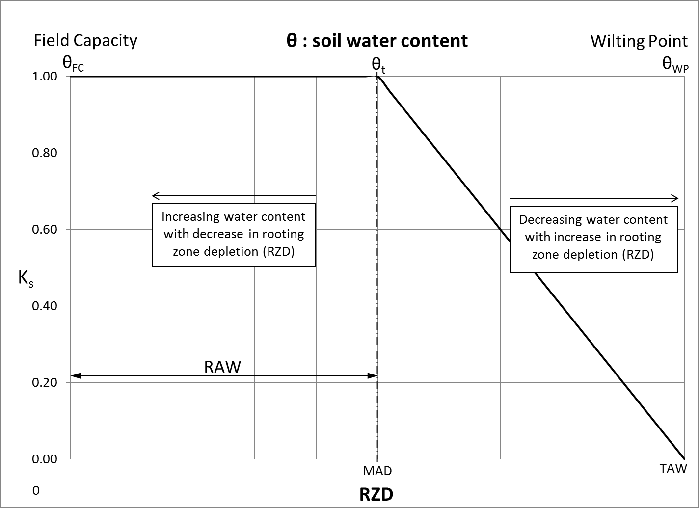
Figure 1: Water Stress Coefficient, K_{S} (Allen, et al., 1998)

Note that different effects have been observed in non-compacted vs. compacted soil. (Typically, turfgrasses grow in compacted soil due to high use while trees, shrubs and gardens grow in non-compacted soil.) Soil compaction can cause water stress to occur in plants when the available water drops below around 80 percent of TAW (Zhang, 2002).

Compacted Soil Water Stress Evapotranspiration (ET_{S}) (Zhang, 2002)

ET_{WSC} = ET_{L}*K_{S} (10)
Where: ET_{WSC} = ET adjusted for water stress (compacted soil)
ET_{L} = ET as determined from the Landscape Coefficient Method
K_{S} = Water stress coefficient:
K_{S} = K_{CWS}*K_{C} (11)
K_{CWS} = 0.003 Θ_{r} + 0.5559 (12)
K_{C} = 0.82 (13)
KC_{WS} = Compacted soil water stress coefficient
Θ_{r} = Relative soil moisture (% of FC)
K_{C} = Compacted soil stress coefficient

Note that within the IDE Tool, only non-compacted soil water stress coefficients are calculated and used in the irrigation demand calculations, regardless of the compaction level specified; compaction in the IDE Tool is used only to adjust the bulk density of the soil, as described earlier in this manual.

Irrigation Losses
Irrigation mechanical performance introduces a variety of losses to irrigated areas. Such losses include, but are not limited to: air losses, canopy losses, soil and surface water evaporation, and deep percolation. Runoff, ground evaporation, and deep percolation are often considered negligible in irrigation design (Rogers, 1997). The IDE Tool independently calculates hydrologic losses due to surface runoff and deep percolation from precipitation but does consider ground (i.e., surface) evaporation negligible for both irrigation and precipitation. Losses associated with irrigation are depicted in Figure 2.

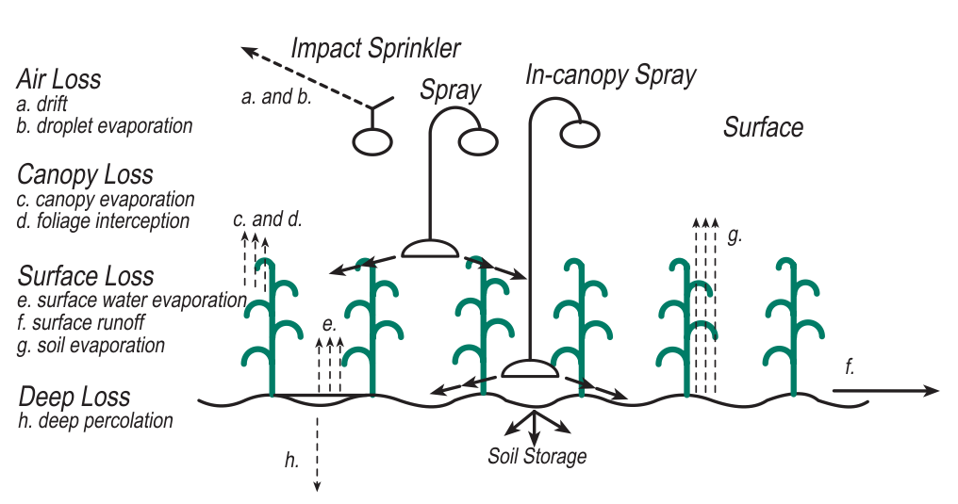
Figure 2: Irrigation Water Losses (Rogers et al., 1997)

As part of irrigation system audits, distribution uniformity (DU) or emission uniformity (EU) can be used to measure the mechanical performance of an irrigation system and allow for an estimate of total water losses over the irrigated area.

DU is used for above-ground distribution methods and is typically calculated based on the net amount of applied irrigation water collected in catch cans. DU for overhead sprinkler irrigation systems varies from 40% for fixed spray to 80% for rotor and impact sprinklers (Mecham, 2004).

EU measures the evenness of drip/micro-irrigation design concepts by comparing the discharges from individual emitters to the total application volume. EU for micro/drip irrigation systems varies from 40% for micro spray to 95% for drip – pressure compensating sprinklers (Irrigation Association, 2005).

The minimum recommended DU and EU values are (IA, 2005):
- Spray – minimum DU of 55%;
- Rotor – minimum DU of 70%; and
- Drip/micro irrigation minimum EU of 80%.

To determine the amount of water required to irrigate the area, the irrigation demand volume is divided by the uniformity value:

V_{REQD} = V_{DEMAND} / DU (14)
V_{REQD} = V_{DEMAND} / EU (15)

The potential losses occurring before the irrigation water reaches the ground include air loss and canopy loss. Air loss includes wind drift of water droplets away from the target irrigation area and evaporation of droplets of water while in flight. Canopy loss includes water held on plants (i.e., foliage interception and evaporation). Once the water reaches the ground, surface losses include runoff, deep percolation, and ground evaporation can occur. When properly designed, runoff, deep percolation, and ground evaporation would be negligible in comparison to the overall water budget.

These losses are considered ‘other losses’ and account for a small amount of the total additional volume required. Table 4 provides an example of the various losses for three sprinkler types assuming surface losses (i.e., ground evaporation, runoff, and deep percolation) are considered negligible (Rogers, 1997).

Table 4: Example Water Losses for Different Sprinkler Types
Sprinkler Type | Air Loss  (%) | Canopy Loss  (%) | Surface Loss  (%) | Total Loss  (%)
Impact Sprinkler | 3 | 12 | - | 15
Spray Head at Truss | 1 | 7 | - | 8
Precision Irrigation | - | - | 2 | 2
While these other losses (LOSS - expressed in percent) would need to be added to the volume of water required for irrigation, they are excluded from the volume of water actually applied to the irrigated area:

V_{XTRA} = V_{REQD} - V_{DEMAND} (16a)
V_{LOSS} = V_{XTRA} x LOSS (16b)
V_{APPLIED} = V_{DEMAND} + V_{XTRA} - V_{LOSS} (16c)

Irrigation System Management Efficiency
Irrigation System Management Efficiency (ISME) accounts for losses as a result of the operation and management of the system. If a system is operated and maintained perfectly, DU, EU and the Other Losses noted above become the only parameters requiring more water to be withdrawn from a source than is applied to the vegetation and soil. However, in reality, efficiency issues with the management and operation of a system are not unusual. Based on discussions with Calgary Parks (pers. comm. with D. Gourdeau and I. Hassan), an ISME factor of 90% was determined as the default value for the IDE Tool, although the user has the flexibility to define a different value. The 90% ISME factor indicates that for 90% of the scheduled time the irrigation system run times will be deliver no more than the necessary amount of irrigation water regardless of changes in weather, soil infiltration, seasonal sun shading, and human error. The ISME tool determines the volume of water withdrawn from a source (V_{PUMPED}), which is in excess of the volume required for irrigation (V_{REQD}) as follows:

V_{PUMPED} = V_{REQD} / ISME (17)

Irrigation Scheduling
A representative irrigation schedule for the period of May through September was established based on discussions with Calgary Parks (pers. comm. with D. Gourdeau and I. Hassan), to determine how Parks would operate a stormwater reuse irrigation system. Irrigation scheduling is defined by the user per individual irrigation area and by the following rules:
- Irrigation only occurs between May 1 and September 30;
- Irrigation only occurs if the preceding 2 days totalled to less than 10 mm of total precipitation;
- Irrigation only occurs during the 5-hour window between 1 am and 6 am;
- Irrigation only occurs if the minimum air temperature is greater than 3°C during the irrigation window (1am to 6am of the following irrigation calculation day); and
- Irrigation for above-ground (i.e., non-drip) irrigation methods will not occur if the hourly wind speed is less than the threshold wind speed (8 km/h or 5 miles/hour by default).

The user is able to override many of these suggested limits within the IDE Tool in the event that different rules are to be followed. Note that if user-defined values are used to override the defaults within the IDE Tool, The City will require documentation justifying the custom values used in the simulation.

IDE Tool Outputs
The IDE Tool produces a variety of results within the Tool itself as well as producing separate output files for further use in other programs.

After a simulation calculation is completed, tabs are generated within the IDE Tool that provide results of the raw calculations, a water balance graph, the annual demand and the monthly demand, the SWC budget, and inputs for the Water Balance Spreadsheet.

The annual and monthly demand results can be viewed either as an equivalent water column depth (mm) or as water volume (m³). When viewing volumetric data, each set of results can be viewed for one single sub-area or as the summation of all the defined areas. Depth results are provided for individual areas only, as summation of water column depths is not appropriate.

The WBSCC tab summarizes the IDE Tool results such that they can be used directly as inputs to the Crop Water Requirements and Weekly Watering Schedule tables in the Water Balance Spreadsheet.

In addition to the tabbed results visible within the IDE Tool, a set of standard PDF documentation files can also be produced. The intent of this PDF output package is to provide a consistent content for format for submissions to The City, streamlining their review process.

In terms of exported files, two different types of time series are generated to provide the user with the necessary input files to represent the results of the IDE Tool simulation in an external SWMM analysis.

The first time series is the volume of stormwater to be withdrawn from a pond (or cistern) for purposes of irrigation. These values are “Pumped Volumes” as defined earlier in this manual. Only one time series is provided, covering the total of all areas defined.

The second time series is the volume of water to be applied to each user-defined irrigation area, considering both precipitation and the estimated applied irrigation requirements, both combined into a single rain gauge dataset. The applied irrigation depths account for irrigation system efficiency, other irrigation losses, or irrigation system management efficiency. Up to 15 irrigation files are generated based on the number of user-defined areas.

Summary of Assumptions and Daily Calculations
The following assumptions and daily calculations are made by the IDE Tool in determining the irrigation volume required to maintain healthy vegetation. Note that if user-defined values are used to override the defaults within the IDE Tool, The City will require documentation justifying the custom values used in the simulation.
- The simulation considers the days from May 1st to September 30th only.
- The water content for each subarea is set to the field capacity of the soil on May 1st of each year. The water content required for this adjustment is referred to as ‘Added Water’ in the water balance results.
- Daily average reference evapotranspiration rates are calculated using historical temperature, relative humidity, and wind speed data.
- Effective precipitation is calculated from the raw precipitation records using the user-defined threshold value. See Section 2.4 for more information.
- The Landscape Coefficient Method, as described in Section 2.6, is used to estimate the base evapotranspiration rate for the selected vegetation type. This rate is further adjusted to account for water stress as outlined in Section 2.7. The user can control the results of the Landscape Coefficient Method by entering a custom species with the appropriate species factor (K_{PS}) attached. The adjustment for water stress may be eliminated by defining a custom soil type with a wilting point (WP) of 0. [Note that a WP of 0 does not result directly in the elimination of water stress effects; the IDE Tool is simply programmed to exclude water stress results for any soil defined with a WP of 0. The wilting point does not affect any other calculations within the IDE Tool.]
- Whether irrigation is assumed to occur requires the following conditions to be met:
  - The day of the week is a scheduled irrigation day (schedule is user-defined).
  - The total precipitation over the previous few days is below the threshold required to cancel irrigation. (Both the number of preceding days to be considered and the amount of precipitation required to cancel the irrigation can be adjusted by the user.)
  - The minimum temperature during the irrigation window (1am to 6am of the following irrigation calculation day) must be greater than or equal to the user-defined minimum air temperature for irrigation.
  - The hourly wind speed between 1 am and 6 am (the assumed irrigation time) must be less than or equal to the user-defined maximum wind speed threshold for irrigation.
- If all of the above conditions are met, irrigation is added to bring the soil water content up to the user-specified target water content - expressed as a multiplier (>1) applied to the field capacity for the selected soil type.
- A preliminary estimate of the water content at the end of the day (PWC) is calculated as follows:

PWC = IWC + P_{ED} + I_{DN} - ET_{L} (18)

- If the PWC is greater than field capacity, deep percolation losses (DP) are assumed to occur. The percolation rate is taken equal to the saturated hydraulic conductivity of the subsoil material, reduced by the user-defined percolation rate safety factor. Percolation losses are limited in order to maintain the EWC at or above field capacity.
- If the PWC exceeds the saturation level of the soil, runoff (R) is assumed to occur and the PWC is reduced to the saturated value.
- The final EWC for the day is calculated as follows:

EWC = PWC – DP - R (19)

- EWC becomes the IWC for the following day (i.e., except for May 1st of each year, when IWC is always set to field capacity through the provision of added water).

PREPARING TO LAUNCH THE IDE TOOL

Obtaining the Latest Version
The latest version of the IDE Tool and User’s Manual can be found on The City of Calgary’s Water development approval submission resources website. It is recommended that the latest version be obtained at the start of each new project. The basic file is approximately 12 MB in size and once downloaded, it can be saved anywhere on the user’s system – on a local drive, network drive or removable drive. Once downloaded, internet access is not required to use or run the IDE Tool with the exception of links to the User Manual (this document), which requires an internet connection.

Excel Requirements
A licensed installation of Microsoft® Excel Version 2010 (or later) is required for the IDE Tool to function properly. Earlier versions may also be acceptable – calculations should be completed correctly but some of the graphs may not display as intended. The IDE Tool also requires that macro execution be enabled within Microsoft® Excel. If macros are not enabled when the IDE Tool is launched, the user will be prompted as shown in Figure 3. If macros are enabled when the IDE Tool is launched, this screen will not be displayed.

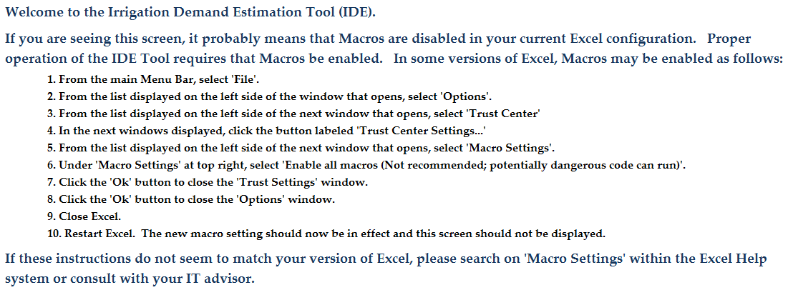
Figure 3: The IDE Tool Instruction Screen for Enabling Macros

Microsoft® Excel Macro Settings
As discussed in Section 3.2 above, if macros are not enabled upon launching the IDE Tool, the user will be prompted to enable macros within Microsoft® Excel. The location of this setting may vary with the version of Microsoft® Excel being used. For Microsoft® Excel 2010, the Macro Settings functionality is located within the Trust Center Settings as shown in Figure 4. For other versions of Microsoft® Excel, the user should consult either the Microsoft® Excel documentation or their own IT support personnel.

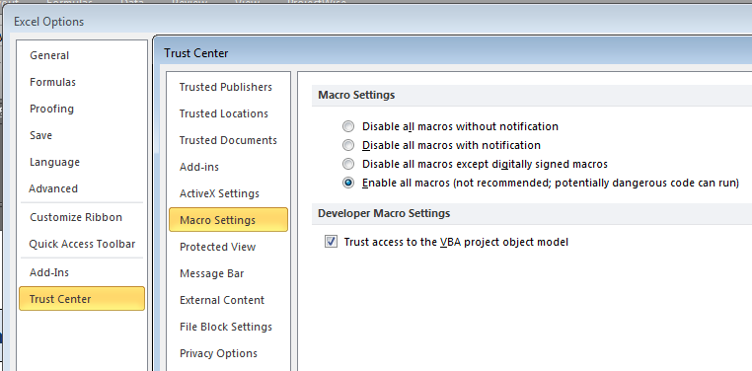
Figure 4: Required IDE Tool Macro Settings (Microsoft® Excel 2010)

Hardware Requirements
The IDE Tool requires a maximum of approximately 75 MB of hard disk space for each run of the tool and full output production. Sufficient physical memory (i.e., RAM) should also be available to minimize the computational time of the IDE Tool.

Terminology
Within this manual, “tab” and “worksheet” are used interchangeably to refer to a single worksheet page within the overall IDE Tool workbook.

LAUNCHING THE IDE TOOL
When macro-enabled Microsoft® Excel is launched, a new start-up screen appears (Figure 5). After clicking the appropriate button, the user will be taken to the Terms and Conditions page (Figure 6). After the Terms and Conditions have been reviewed and agreed to by the user, a window will appear asking the user to select an activity: edit existing data, view existing results, start a new analysis, or cancel the application (Figure 7). If the workbook does not contain either existing input data or existing results, those options will not be displayed.

Figure 5: Macro-enabled Start Screen

Note, in some versions of Excel it is necessary to enable Active Content by clicking “Options” and then “Enable this Content”. If the workbook opens in Protected View, click “Enable Editing”. If this produces an error, closing and reopening the workbook should produce the screen shown in Figure 5.

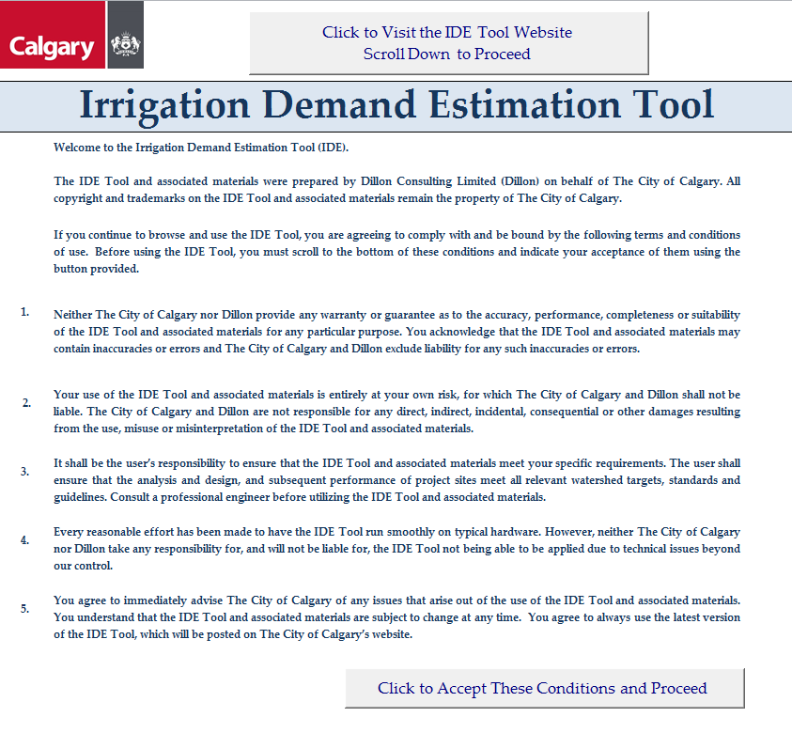
Figure 6: Terms and Conditions Page

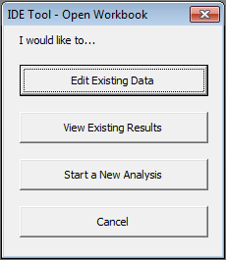
Figure 7: IDE Tool Selection Window

USING THE IDE TOOL

IDE Tool Organization
The IDE Tool is divided into five categories including: (1) Project Information, (2) Simulation, (3) Results, (4) Graphs, and (5) Outputs. Figure 8 illustrates the overall organization of the tool. The first four categories (all except Outputs) are contained within the IDE Tool itself, and the individual headings in Figure 8 relate to worksheet or tab names. The “Outputs” all refer to external files produced and saved in the same folder as the IDE Tool.

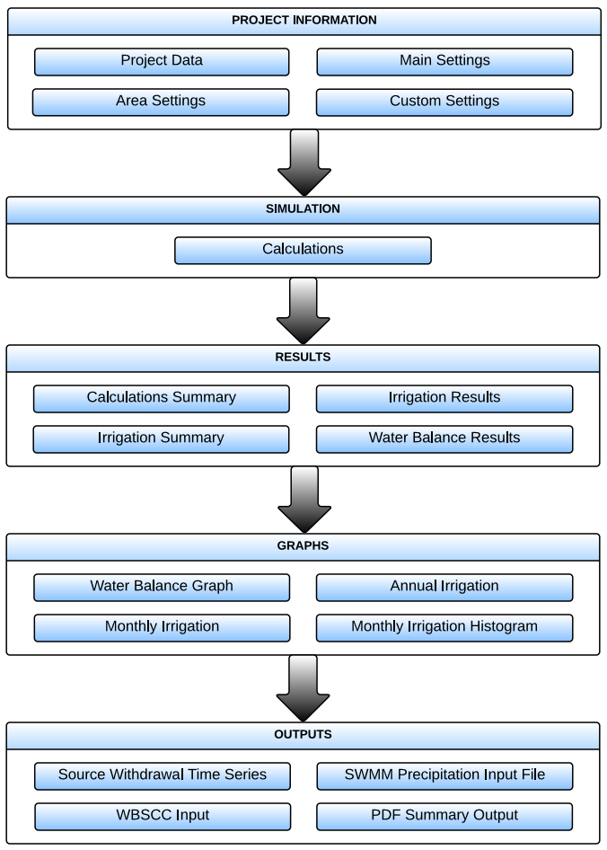
Figure 8: The IDE Tool Organization

Data Entry and Viewing
Performing an irrigation demand simulation using the IDE Tool requires worksheets Project Data, Main Settings and Area Settings to be completed. The user cannot see any data used (e.g., climate data) for the internal calculations prior to the simulation being run. For optimal viewing and user functionality, the spreadsheet should be kept on “Normal View”.

Project Information
The ‘Project Information’ section of the IDE Tool encompasses the following four worksheet tabs:
- Project Data;
- Main Settings;
- Area Settings; and
- Custom Settings (user-entry window opens when Checkbox “Allow custom entries” is selected).

Project Data
The Project Data worksheet provides an area for the user to document relevant information about the project including the project name, description, location, date, company, designer, and reviewer. The IDE Tool will perform the simulation calculations whether or not this information is provided but production of the PDF output package will not be completed without this information.

Several buttons are provided on the Project Data worksheet to complete various operations. As shown on Figure 9, the buttons include:
- Clear All – clears all user input data and resets all default values in the entire workbook. The button also turns off the use of custom entries (described further in a later section of the manual) but does not erase previously created custom entries.
- Clear Sheet – clears user input data on the Project Data tab only.
- Output – generates output files for The City of Calgary submissions, SWMM, and WBSCC files. Calculations must be completed and project information must be entered for this button to function. If either of these conditions is not met when this button is pressed, an error message will be displayed.
- Help – directs users to the IDE Tool User Manual (this document), located on The City of Calgary website:
IDET User Manual
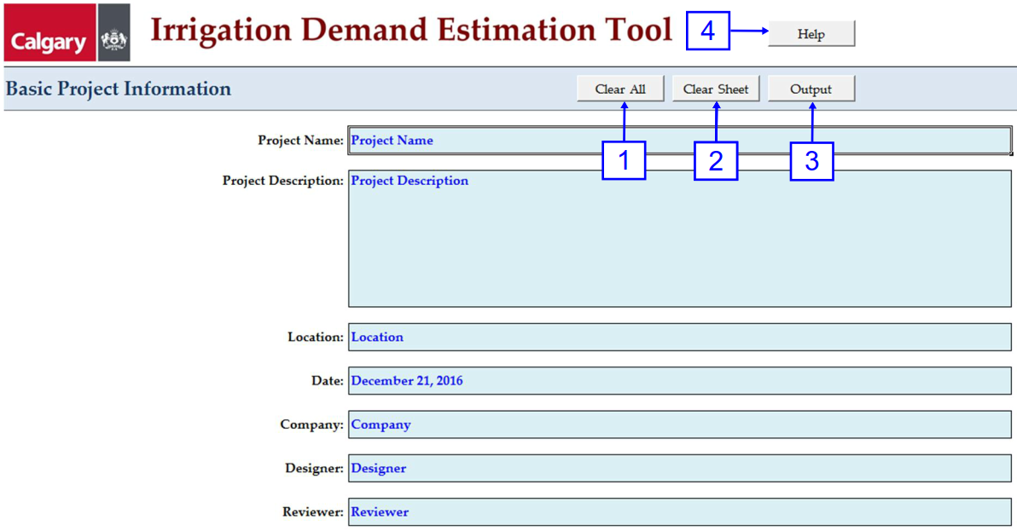
Figure 9: Project Data Worksheet

Main Settings
The Main Settings worksheet contains global data settings which apply to the irrigation demand calculations for all areas. The worksheet has default settings defined but provides the user with the flexibility to enter more site-specific values. The page includes a validation function to check that all entries are within the appropriate ranges as identified in Table 5. See the Glossary in Appendix B for detailed definitions of each entry. Validation can be completed manually using the button provided and is also run automatically before calculations are started.

Table 5: “Main Settings” Worksheet Entries
Entry | Units | Default Value | Permitted Range
Percolation Rate Safety Factor | - | 1 | 1 – 3
Precipitation Adjustment Factor | - | 1 | 0.5 – 1.5
Effective precipitation threshold | mm | 5 | 0 – 10
Precipitation required to cancel irrigation | mm | 10 | >= 0
Number of preceding days over which precipitation is checked | days | 3 | <=3
Minimum air temperature threshold for irrigation | ºC | 3 | 0 - 5
Maximum wind speed threshold for irrigation | km/h | 8 | >= 5
Irrigation target water content | - | 1.10 | 0.6 – 1.5
Management Allowable Depletion (MAD) | % | 50 | 0 – 100
Irrigation system management efficiency | % | 90 | 0 – 100
Rain gauge ID | - | 3031093 | 7 characters

As shown in Figure 10, the Main Settings worksheet contains several buttons that perform specific functions including;
- Validate – checks allowable ranges for variables as identified in Table 5;
- Area Settings – jumps to the Area Settings worksheet tab;
- Defaults – restores all values on this sheet to defaults (does not erase custom entries);
- Help – directs users to the IDE Tool User Manual; and
- Calculate – runs the irrigation simulation calculations.

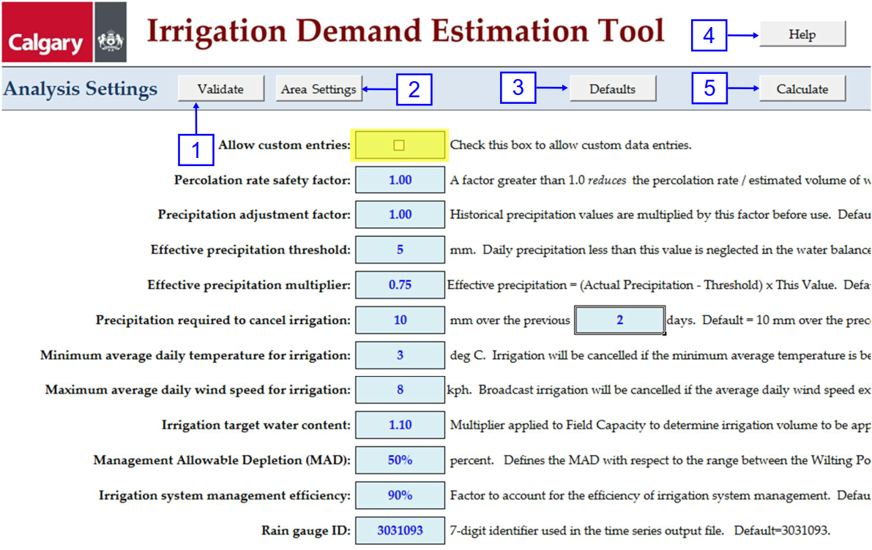
Figure 10: Main Settings Worksheet

The Main Settings worksheet is also where the user can access custom entries for soil types, irrigation methods, and vegetation species. To activate this setting, the box highlighted in yellow on Figure 10 must be checked. When the box is checked, an additional button is displayed on the sheet as shown on Figure 11. To access the custom entries editor, click the ‘Edit…’ button.

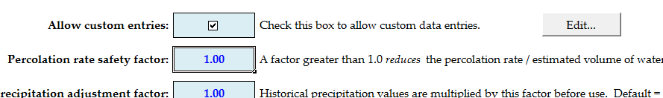
Figure 11: Custom Entries Access from the Main Settings Worksheet

Custom Settings
The IDE Tool provides default values for most parameters. However, a project may require the use of site-specific data that is not included as a default value. The Custom Settings worksheet provides the user with a way to add additional parameters to the IDE Tool pertaining to soil type, irrigation method, and vegetation species. The worksheet containing the custom entries can be accessed by first clicking the ‘Allow custom entries’ box then clicking the ‘Edit…’ button on the Main Settings worksheet. A summary of the custom entry parameters is provided in Table 6. When custom entries are used, The City reviewers will expect to see information in the ‘Source’ field justifying the custom values entered.

Table 6: Custom Entry Data Fields
Category | User Defined Value | Units | Note
Soil  Types | Description | - | Name of user-defined soil
 | Water Holding Capacity at Saturation | fraction | Manually enter
 | Water Holding Capacity at Field Capacity | fraction | Manually enter
 | Water Holding Capacity at Wilting Point | fraction | Manually enter
 | Saturated Hydraulic Conductivity | mm/hr | Manually enter
 | Source | - | Reference specifying the source or backup for custom values
 | Maximum number of custom soil types | - | 3
Irrigation Method | Description | - | Name of user-defined irrigation method
 | Efficiency | % | Manually enter
 | Other Losses | % | Manually enter
 | Below Grade | - | Choose from drop-down list
 | Source | - | Reference specifying the source or backup for custom values
 | Maximum number of custom methods | - | 3
Vegetation Species | Description | - | Name of user-defined vegetation species
 | Vegetation Type | - | Choose from drop-down list
 | Demand Level | - | Choose from drop-down list
 | Species Factor, K_{PS} | - | Manually enter
 | Source | - | Reference specifying the source or backup for custom values
 | Maximum number of custom species | - | 10

Selection of the custom entries in the calculations occurs by selecting the entry in the pop-up windows for Topsoil Type, Subsoil Type, Vegetation Type (K_{PS}), and/or Irrigation Method on the Area Setting worksheet. This is explained further in Section 5.3.4 of this manual.

The user has the ability to define up to three custom soils, three custom irrigation methods, and 10 custom vegetation species. When a custom entry is created, a source providing background information about the entry is expected. A screen shot of the Custom Settings worksheet is shown on Figure 12.

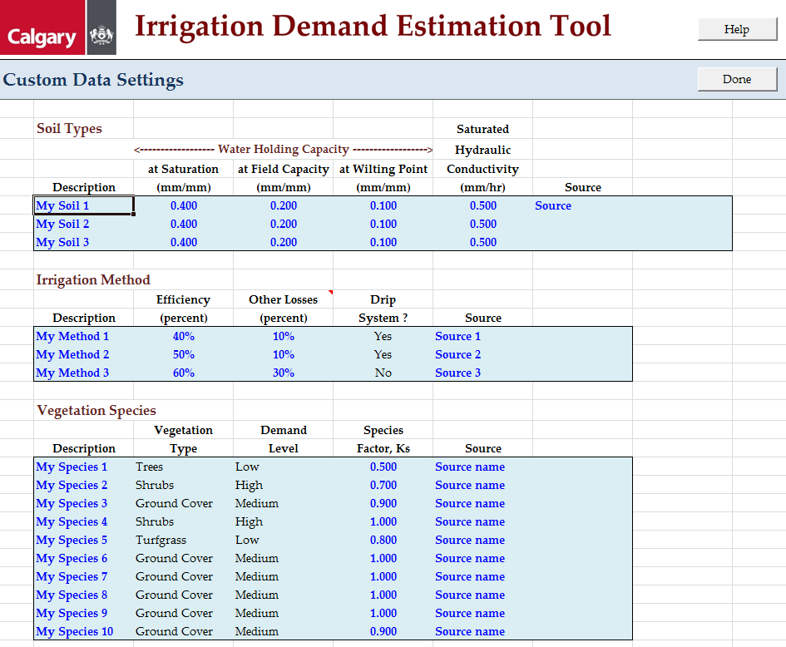
Figure 12: Custom Entries Editor

Area Settings
The Area Settings worksheet tab is where the user defines the individual areas making up the total irrigation area. There are two methods the user can use to define the plan extent of the areas: Summation or Definition. Table 7 provides a summary of the two methods. When using the Summation method, the user enters the area, in hectares, of each individual irrigation area in the appropriate cell in Column D. When using the Definition method, the user enters the total irrigation area in cell C6 and the fraction of the total area represented by each individual irrigation area in the appropriate cell in Column D. Figures 13, 14 and 15 show example input data using the two methods.

Table 7: Area Setting Worksheet –Area Determination Method
Total Area Determination | Definition | Units in Column D
Summation | The total area is determined by summing each individual area. | hectares
Definition | Each area is determined by prorating the total irrigated area by the relative size of the area. | relative size of area - unitless

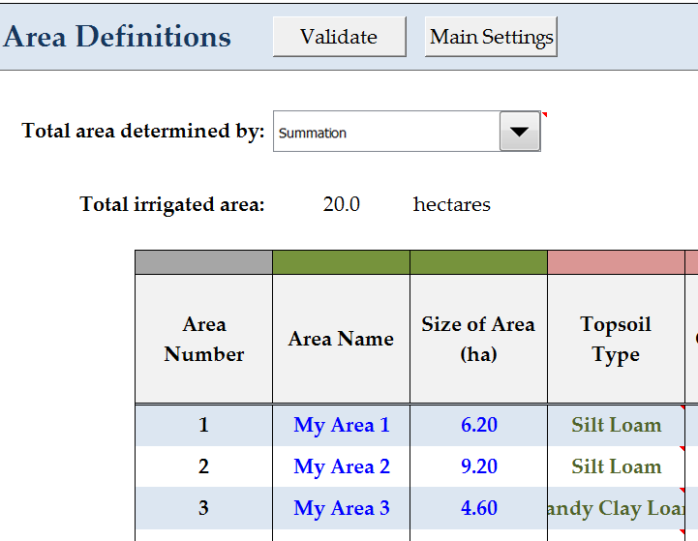
Figure 13: Area Determination by Summation

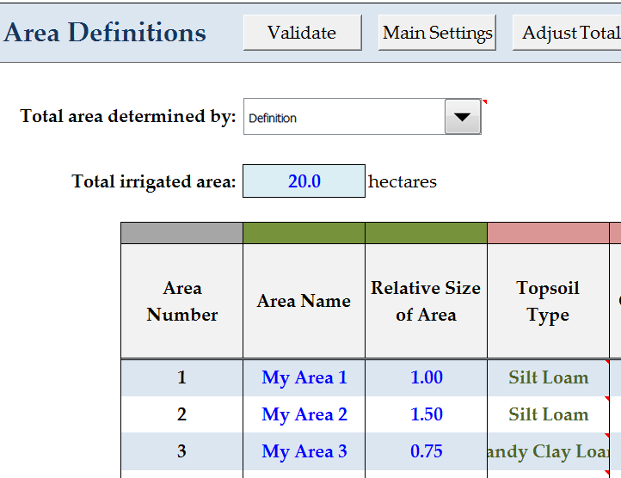
Figure 14: Area Determination by Definition (Prior to Clicking ‘Adjust Total’)
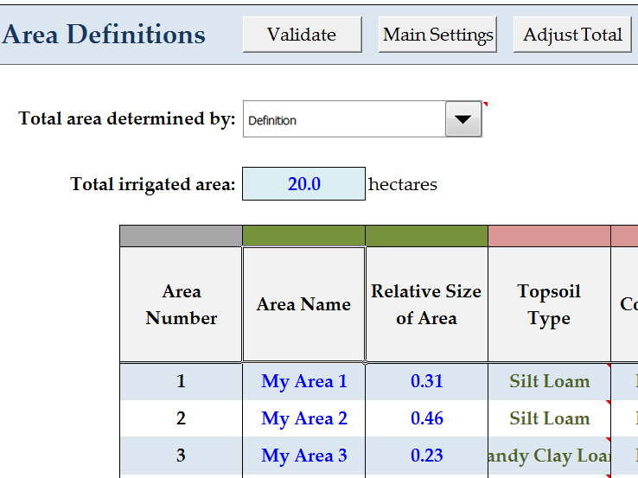
Figure 15: Area Determination by Definition (After Clicking ‘Adjust Total’)

In Figure 13, the total extent of 12 ha is determined within the IDE Tool by summing the three individual areas that have been defined.

In Figure 14, the extent of the individual areas will be calculated by the IDE Tool as follows:
My Area 1 = 20 ha x 1.00 / [ 1.00 + 1.50 + 0.75 ] = 6.2 ha
My Area 2 = 20 ha x 1.50 / [ 1.00 + 1.50 + 0.75 ] = 9.2 ha
My Area 3 = 20 ha x 0.75 / [ 1.00 + 1.50 + 0.75 ] = 4.6 ha
Total = 20.0 ha

In Figure 15, the extent of the individual areas will be calculated by the IDE Tool as follows:
My Area 1 = 20 ha x 0.31 = 6.2 ha
My Area 2 = 20 ha x 0.46 = 9.2 ha
My Area 3 = 20 ha x 0.23 = 4.6 ha
Total = 20.0 ha

Note that there is no difference between the areas shown in Figure 14 and Figure 15.

The remainder of the entries for each area can be made either by double-clicking on a cell to activate a pop-up window in which the user selects the appropriate value or by manually entering the value into the cell. A color coding system is provided in Row 8 above each of the data entry columns to show the data entry method applicable to each column.

Columns C, D, G, and M contain values entered directly by the user. Columns B and N do not require any input by the user. The remaining columns contain values that are chosen from pop-up windows, which can be engaged by double-clicking on the cell of interest. Figure 16 shows an example of a pop-up window. Table 8 summarizes how to make entries on the Area Settings worksheet and provides valid ranges of the data for the irrigation simulation calculations to run. If custom entries have been defined by the user, and the use of custom entries has been selected on the Main Settings worksheet tab, these custom entries will be available in the relevant pop-up windows.

If an area is unnamed in Column C but has values in the other columns, the IDE Tool will automatically name the areas in sequential order (e.g., Area 1, Area 2, Area 3, etc.) when the data is validated.

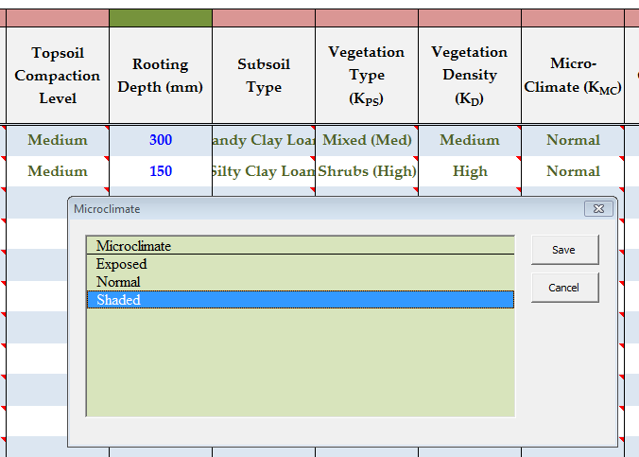
Figure 16: Area Settings Worksheet – Example Pop-up Window

Table 8: Area Settings Worksheet Values
Value | Units | Selection Method | Valid Value
Area Name | - | manually entered | -
Size of Area¹ | ha | manually entered | > 0
Relative Size of Area² | fraction | manually entered | > 0
Topsoil Type | - | double click → pop-up window | selected from pop-up window
Topsoil Compaction Level | ⁻ | double click → pop-up window | selected from pop-up window
Rooting Depth | mm | manually entered | 50 – 1000
Subsoil Type | - | double click → pop-up window | selected from pop-up window
Vegetation Type (K_{s} ) | - | double click → pop-up window | selected from pop-up window
Vegetation Density (K_{d}) | - | double click → pop-up window | selected from pop-up window
Micro-Climate (K_{mc} ) | - | double click → pop-up window | selected from pop-up window
Landscape Coefficient Method | - | double click → pop-up window | selected from pop-up window
Defined Landscape Coefficient (K_{L}) | - | manually entered | > 0 (if used)
Calculated Landscape Coefficient (K_{L}) | - | automatically calculated | -
Irrigation Method | - | double click → pop-up window | selected from pop-up window
Irrigation Schedule | - | double click → pop-up window | selected from pop-up window
Note 1 – Based on Summation Method to determine the total area based on defined individual areas
Note 2 – Based on Definition Method to determine to individual areas based on a defined total area

Several buttons can be found on the Area Settings tab as shown in Figure 17. The available buttons include:
- Validate – checks allowable ranges for variables as identified in Table 8.
- Main Settings – jumps to Main Settings tab.
- Adjust Total – adjusts the ‘Relative Size of Area’ given in the table so that the sum of the Relative Size of Area column equals 1.0 (only available when Total Area is being determined by Definition).
- Help – directs users to the IDE Tool User Manual (this document) on The City of Calgary website.
- Calculate – runs the irrigation simulation calculations.

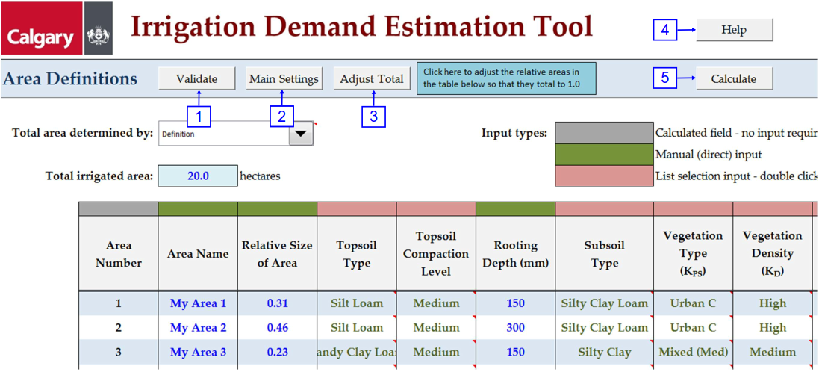
Figure 17: Area Settings Worksheet (Definition Method)

The maximum number of discretized irrigation areas that can be defined in a single run is 15. If the user requires more than 15 areas, multiple runs of the IDE Tool are necessary.

Initiating Analysis
Prior to the simulation calculations being completed, a validation of the data entered on the Main Settings and Area Settings tabs will be completed. If any errors are found, a message will be displayed, and the calculations will not be completed. Figure 18 shows a sample validation error.

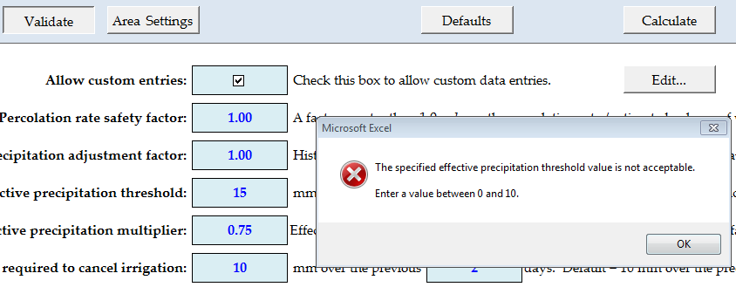
Figure 18: Example of an Invalid Entry and Failed Validation

Once all data has been successfully validated, clicking the Calculate button on either the Main Settings or Area Settings worksheets (shown in Figures 10 and 17, respectively) will initiate the simulation calculations. While the simulation is calculating results, a progress screen will appear allowing the user to monitor the status of the calculations (Figure 19).

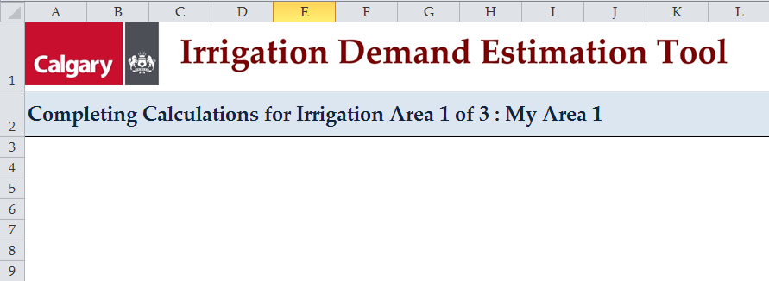
Figure 19: Calculation Progress Screen

Results
Upon completion of the calculations, nine new tabs become visible to the user. Summaries of the simulation are provided on the first five tabs with interactive graphs of the results making up the final four tabs. Additionally, the three original data entry tabs become locked to protect the user from making changes to the input data without generating new results (Figure 20 and Figure 21). When the IDE Tool is unlocked to once again allow data entry (through the ‘Unlock’ button visible in Figures 20 and 21), all results disappear and execution of the analysis calculations will have to be repeated. Each of the results tabs provides the user different information about the simulation.

The new tabs include:
- Calculation Summary Worksheet;
- Calculations Worksheet;
- Irrigation Results Worksheet;
- Irrigation Summary Worksheet;
- Water Balance Results Worksheet;
- Water Balance Chart;
- Annual Irrigation Chart;
- Monthly Irrigation Chart; and
- Monthly Irrigation Histogram Chart.

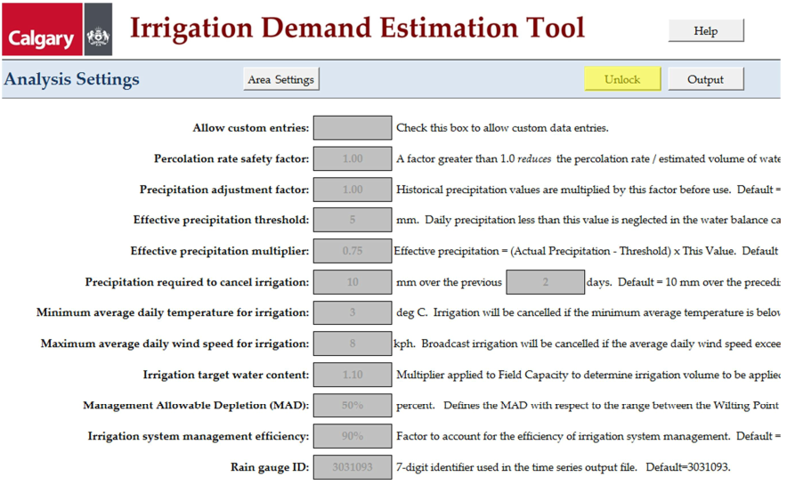
Figure 20: Locked Main Settings Worksheet

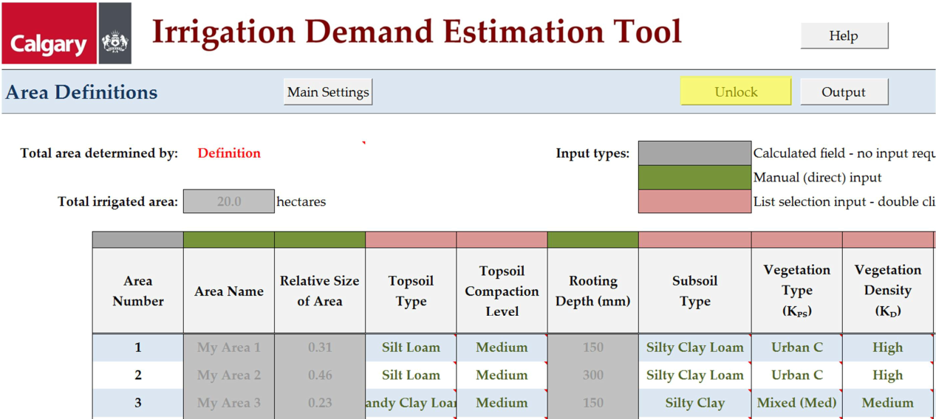
Figure 21: Locked Area Settings Worksheet

Results - Calculations

Calculations Worksheet
The calculations are completed on the aptly named Calculations tab that will become visible after the calculations are complete. While this worksheet is not intended as the primary location to review the calculation results, a brief description of the contents of each column will be provided below. Columns to the right of those listed here contain data used for graphing, and are not described further in this manual. Each row on the calculation sheet represents a single day.

The Calculations tab displays the results for one individual area at a time. The area to be displayed is selected using the drop-down listed at the top left corner of the page near Cell C2 (Figure 22).

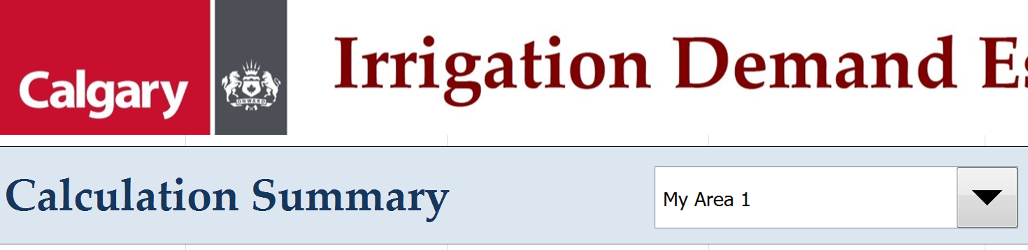
Figure 22: Dropdown to Select Which Area’s Calculations Are Displayed

Column | Heading | Description
A | Date | The full date
B | Year | The year
C | Month | The month number (January = 1, etc.)
D | Day of Year | The day number within the year (January 1 = 1, etc.)
E | Day of Month | The day of the month
F | Day of Week | The day of the week (Sunday = 1, etc.)
G | Minimum Air Temp | Minimum air temperature for the specified day
H | Reference Evapotranspiration | Reference evapotranspiration calculated from historical temperature, relative humidity and wind speed data.
I | Average Wind Speed | Average wind speed between the hours of 1 am and 6 am, from Environment Canada records
J | Raw Daily Precipitation | Daily precipitation – from Environment Canada records
K | Adjusted Daily Precipitation | The Raw Daily Precipitation multiplied by the precipitation adjustment factor defined on the Main Settings tab
L | Effective Precipitation | See Section 2.4 of this manual
M | Added Water Content | Water content added on May 1st of each year in order to restore the water content to field capacity
N | Initial Water Content | Water content in the soil column at the start of the current day
O | Not Used
P | Base Plant Evapotranspiration | Value from Column H x Landscape Coefficient
Q | Evapotranspiration Multiplier | Multiplier to account for water stress. See Section 2.7 of this Manual.
R | Estimated Plant Evapotranspiration | Column P x Column Q – the expected evapotranspiration after adjusting for water stress effects
S | Irrigation Day? | Is this day of the week a schedule irrigation day?
T | Precipitation over Previous X Days | Total precipitation falling over the previous ‘X’ days. ‘X’ changes based on the setting on the Main Settings tab.
U | Irrigation Precipitation Check | Checks if irrigation is permitted on the current day based on the limits imposed on precipitation on preceding days
V | Warm Enough to Irrigate? | Checks if irrigation is permitted on the current day based on the specified temperature limit
W | Wind Low Enough to Irrigate? | Checks if irrigation is permitted on the current day based on the specified wind speed limit
X | OK to Irrigate? | Based on all the checks in preceding columns, is irrigation permitted on the current?
Y | Irrigated Yesterday? | Was the area irrigated yesterday?
Z | Not Used
AA | Irrigation Amount | Amount of irrigation (in mm) required to bring the water content of the soil up to the specified limit
AB | Preliminary Water Content | Calculated end of day water content before considering losses due to deep percolation and runoff
AC | Deep Percolation Losses | Calculated deep percolation losses
AD | Runoff Losses | Calculated runoff losses
AE | Ending Water Content | Final ending water content for the day, after considering deep percolation and runoff losses
AF | Irrigation Volume | Amount of irrigation (in m³). Calculated from the value in column AA and the plan extent of the area

Results - Worksheets

Calculations Summary Worksheet
The Calculations Summary worksheet summarizes the simulation results for each discretized irrigated area as defined on the Area Settings worksheet. The user can choose an irrigated area to review from the drop-down list located at the top of the worksheet (near Cell C2, see Figure 22). The worksheet summarizes all input data, topsoil layer properties, the irrigation schedule, the irrigation demand before and after all efficiency factors, and the precipitation for the 55 year (May through September) simulation.

Irrigation Results Worksheet
The Irrigation Results worksheet summarizes the total irrigation demand for each discretized irrigation area or the aggregate of all areas combined. The summary is broken down by year (1960 – 2014) and by month (May – September) and also shows the total demand over the 55 year simulation, average annual demand, and average monthly demand as well as the overall monthly average, and the standard deviation. The summary can be transformed into depth (mm), demand volume (m³), applied volume (m³), or pumped volume (m³). Figure 23 is an example of the Irrigation Results worksheet for the “pumped volume” option. Note that the various volume results are only available for ‘All Areas Combined’, as a combination of irrigation depths is not appropriate.

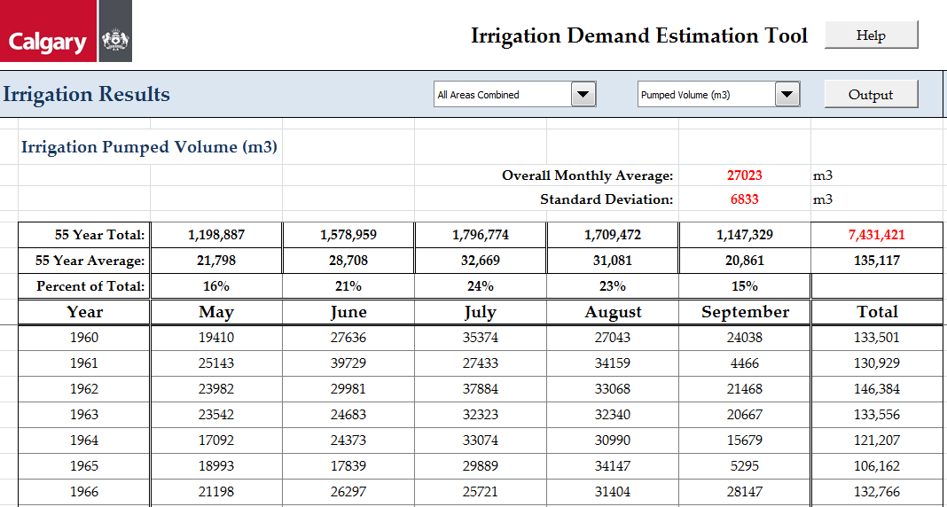
Figure 23: Irrigation Results Worksheet Example

Irrigation Summary Worksheet
The Irrigation Summary worksheet is a simplified version of the Irrigation Results worksheet providing the average annual volumes (m³) for the demand, applied, and pumped totals by the discretized and aggregate area(s). The worksheet also provides the average monthly applied irrigation (mm) by discretized area. Figure 24 is an example of the Irrigation Summary worksheet.

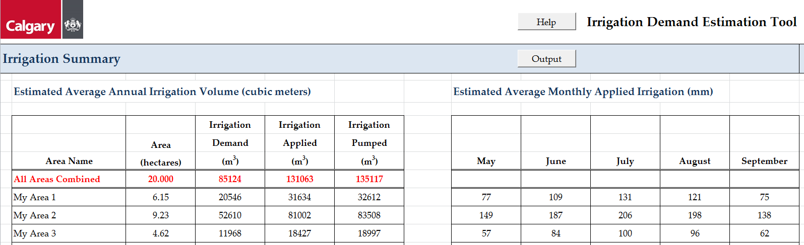
Figure 24: Irrigation Summary Worksheet Example

Water Balance Results Worksheet
The Water Balance Results worksheet is a check-book summary of the simulation. It is assumed the IWC is at field capacity on May 1st of each year. Therefore, the simulation begins on May 1, 1960 with the IWC at field capacity. After September 30th of each year, a volume of water is added if required to return the SWC to field capacity on May 1st of each subsequent year. The balanced water budget is based on the irrigation demand, not the applied volume or pumped volume. The applied volume and pumped volume introduce excess volume to the system as a result of inefficiencies within the irrigation system.

The water balance results can be viewed in terms of depth of water (in which case the total for ‘All Areas Combined’ is not available), by volume or by relative quantities. There is no significance to the absolute magnitude of the “relative quantities”; this display simply provides an easy way to visualize the relative magnitude of each element in the balance equation.

The ‘Balance Check’ (Column L) should always be equal to zero, indicating that water balance equation is indeed balanced.

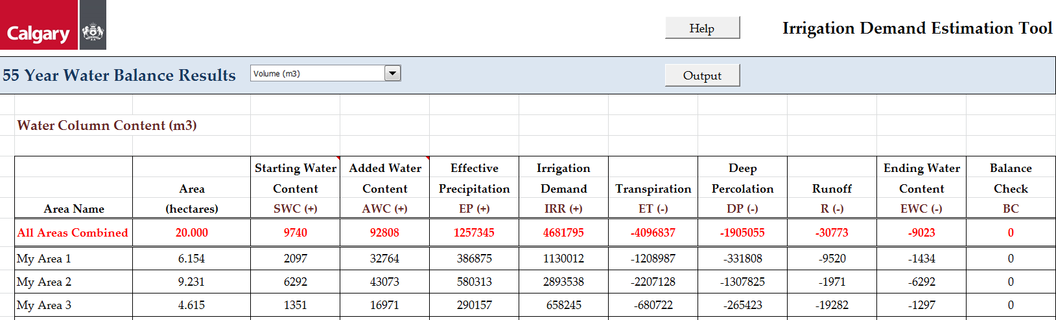
Figure 25: Water Balance Results Worksheet Example

Results - Charts

Water Balance Chart
The Water Balance Chart provides an interactive graphical representation of the simulation results for each discretized area. The aggregate area is not available on this worksheet and only one tributary area can be selected at a time. The user can use drop-down lists to define the range of months and years the graph should display (see the top left region of Figure 26). Clicking on the ‘All Dates’ button graphs May 1, 1960, through September 30, 2014. October through April is omitted on the graph. The graph plots effective precipitation and irrigation demand on an inverted Y-axis. SWC, saturation, field capacity, and wilting point are plotted on a normal Y-axis. The X-axis is the time. Figure 26 provides an example of the Water Balance Graph.

Inadvertently, due to some unexplained issues within the Excel program itself, the lines showing wilting point, field capacity and saturation will sometimes disappear from the display. A button to restore these lines to the display is provided at the bottom right corner of the chart.

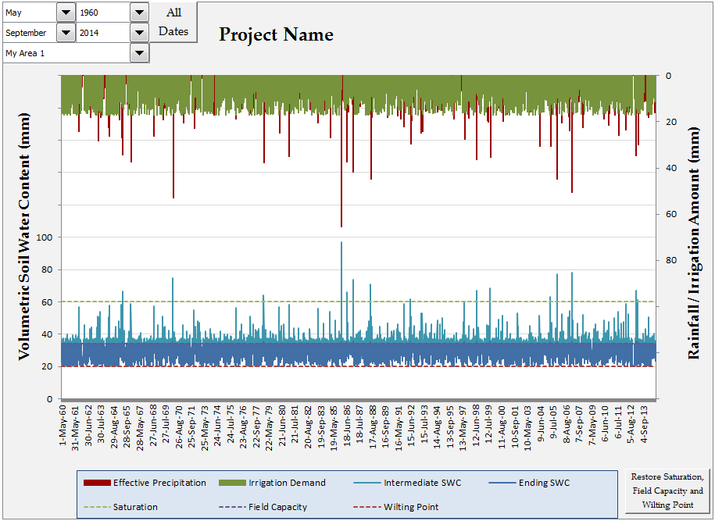
Figure 26: Water Balance Graph Example

Annual Irrigation Chart
The Annual Irrigation worksheet provides a graphical summary of the annual irrigation demand (expressed in either mm or m³) or the applied or pumped volumes as well as the calculated average and standard deviation for the selected years. The user can select to display the discretized irrigation areas or the total aggregate area (volumes only). Drop-down lists provide flexibility for the user to select which value to graph and over which time frame. Figure 27 provides an example of the Annual Irrigation Chart.

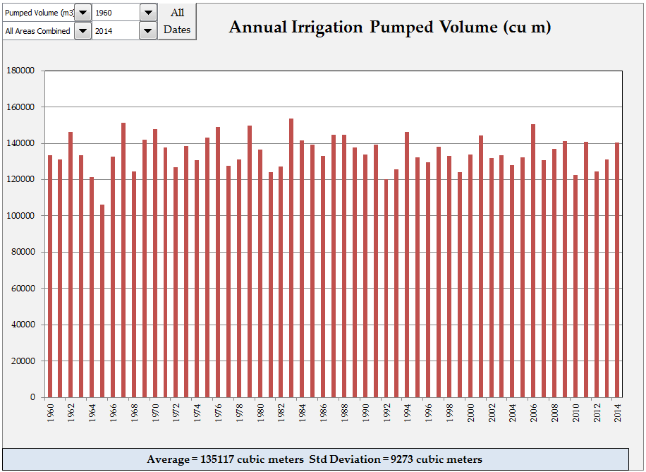
Figure 27: Annual Irrigation Chart Example

Monthly Irrigation Chart
The Monthly Irrigation chart provides a graphical display similar to the Annual Irrigation chart, except that values are plotted on a monthly instead of an annual basis. Figure 28 provides an example of the Monthly Irrigation Chart.

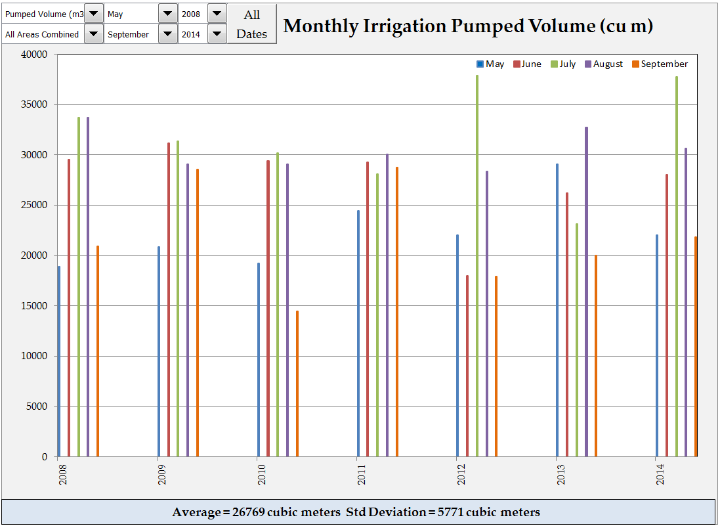
Figure 28: Monthly Irrigation Chart Example

Monthly Irrigation Histogram Chart
The Monthly Irrigation Histogram chart provides a frequency distribution histogram of the monthly irrigation demand (in mm or m³) or the applied or pumped volume. The user can select to display the discretized irrigation areas or the total aggregate area (for volumes only). Drop-down lists provide flexibility for the user to select which value to graph and over which time frame. Figure 29 provides an example of the Monthly Irrigation Histogram.

The horizontal axis of this chart represents the monthly irrigation quantity while the vertical axis shows the number of months (over the selected period) for which this quantity was valid.

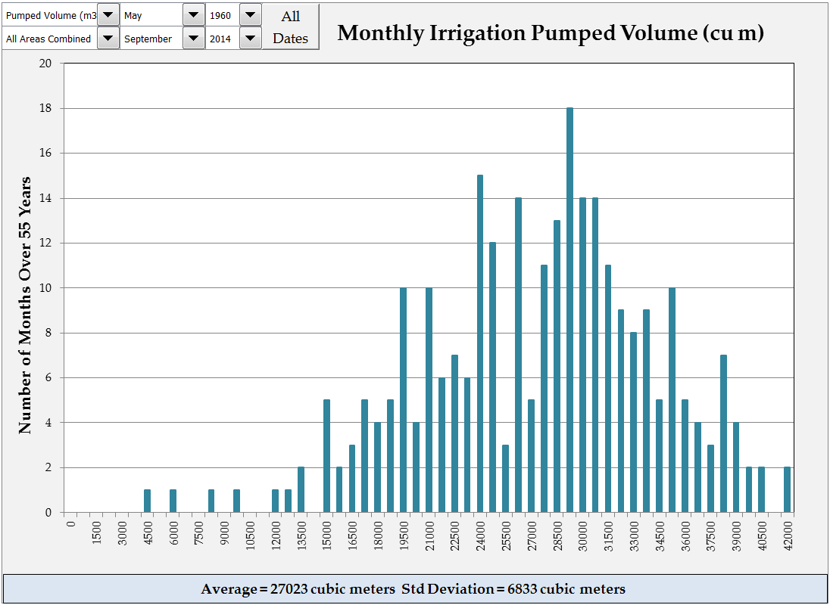
Figure 29: Monthly Irrigation Histogram Example

Outputs
After running a successful simulation, when the user clicks on the “Output” button, the simulation is summarized in a PDF report and the pond withdrawal and “irrigation + precipitation” time series’ text files are generated. An example of the location of the Output button is shown on Figure 9 and Figure 20. An example of the PDF output and screenshots of the time series’ are located in Appendix A.

The files include a time series used to simulate withdrawing water from the source, a combined irrigation and precipitation file for each discretized area, and a portable document format (PDF) file summarizing the results of the analysis and intended for inclusion with any submission to The City for review.

SWMM Source Withdrawal Time Series
The time series represents the pumped volume of stormwater withdrawn from one source (i.e., stormwater pond) for reuse purposes (e.g., irrigation). The time series is continuous on an hourly basis from January 1, 1960, through December 31, 2014. The difference between the volumes pumped from the source and that applied to the soils and vegetation is a result of the irrigation system management efficiency (ISME).

SWMM Combined Precipitation and Applied Irrigation File
For each discretized area, a separate time-series output file is created. The file represents the combination of precipitation and applied irrigation water (in units of 0.1 mm) to be returned to the vegetation and soils as additional precipitation (i.e., the delivery is modelled through a SWMM rain gauge that is a combination of both known precipitation and calculated applied irrigation). The file is created in the standard record format as adopted for climatological data for hourly data by Environment Canada (source: http://climate.weather.gc.ca/prods_servs/documentation_index_e.html).

STN ID |  |  |  |  |  |  | YR |  |  |  | MO |  | DY |  | ELEM |  |  | VALUE
Figure 30: Combined Precipitation and Applied Irrigation File Format

Where: STN ID = Unique station identification
YR = Year
MO = Month
DY = Day
ELEM = Element (123 is hourly rainfall with units of 0.1mm)
VALUE = Depth of precipitation in units of 0.1mm, repeated 24 times

WBSCC Input
Results from the IDE Tool can be used to refine the inputs to the WBSCC. The following entries in the SD tab of the WBSCC can be adjusted using IDE Tool model entries/results (located on the “WBSCC Input Data” sheet of the IDE Tool):
- Average monthly values of crop water requirements for each subcatchment modelled with irrigation based on the calculated irrigation demand areas.
- The weekly watering schedule by month for each subcatchment modelled with irrigation areas based on the calculated irrigation pumped amount.

Subcatchment parameters and precipitation threshold value entered in the WBSCC must correspond to those used in the IDE Tool (i.e., soil parameters, vegetation type, Ground Cover Crop-Mix Profiles).

PDF Summary Output
The PDF output is a summary of all the input and results from the IDE Tool analysis. This PDF summary should be included with all submissions to The City pertaining to stormwater reuse and irrigation. A sample output package is included in Appendix A.

References
Alberta Agriculture. (n.d.). Interpolated Weather Data Since 1961 for Alberta Townships. Last accessed: April 27, 2016, from http://agriculture.alberta.ca/acis/township-data-viewer.jsp

American Society of Civil Engineers (ASCE). 2005. The ASCE Standardized Reference Evapotranspiration Equation. Edited by R.G. Allen, I.A. Walter, R. Elliot, T. Howell, D. Itenfisu, and M. Jensen. New York, NY: American Society of Civil Engineers.

Farmwest. (n.d.). Effective Precipitation. Last accessed: May 05, 2016, from http://www.farmwest.com/node/934

Food and Agriculture Organization of the United Nations (FAO). 1998. Crop Evapotranspiration: Guidelines for Computing Crop Water Requirements. Irrigation and Drainage Paper #56. Rome

Irrigation Association of British Columbia. (IABC) 2004. Turf and Landscape Irrigation Scheduling.

Irrigation Association. 2005. Turf and Landscape Irrigation Best Management Practices.

Mecham, Brent. 2004. Using Distribution Uniformity to Evaluate the Quality of a Sprinkler System. Irrigation Association.

Maulé, C., Helgason, W., McGinn, S., Cutforth, H. 2006. Estimation of standardized reference evapotranspiration on the Canadian Prairies using simple models with limited weather data. Canadian Biosystems Engineeering.

Rogers, D.H., Lamm, F.R., Alam, M., Trooien, T.P., Clark, G.A., Barnes, P.L., Mankin, K. 1997. Efficiencies and Water Losses of Irrigation Systems.

Saxton, Keith. 2006. SPAW - Soil Water Characteristics. Washington State University: USDA Agricultural Research Service.

Westhoff Engineering Resources, Inc. 2011. User Manual for Water Balance Spreadsheet Version 1.2.

Zhang, W. 2002. The Impacts of Soil Compaction on Irrigation and Drainage of Golf Course. The University of British Columbia, Faculty of Graduate Studies.

Appendix A
IDE Tool Sample PDF Output
and
Time Series Output Files
Appendix B
Glossary

Applied volume, m³: The volume of irrigation water physically applied to the irrigated area. Applied volume is greater than the demand volume as a result of inefficiencies in the irrigation system.
Demand volume, m³: The volume of irrigation water required to maintain the specified effective water column height.
Density factor, K_{D}: Factor used in the landscape coefficient method to account for the effect of planting density on actual evapotranspiration.
Distribution uniformity, DU: Measure of an above-ground irrigation system’s ability to distribute water evenly across the irrigated area.
Effective precipitation threshold: The daily precipitation level required to be reached before the precipitation is assumed to be effective. Daily precipitation values less than this amount are not included in the calculations.
Emission uniformity, EU: Measure of a buried irrigation system’s ability to distribute water evenly across the irrigated area.
Evapotranspiration, ET: Loss of water from the soil through vegetation.
Field capacity, FC: The water holding capacity of a given soil.
Irrigation system management efficiency, ISME: A measure of how well an irrigation system is operated and managed.
Irrigation target water content: The target water content for irrigation. In the IDE Tool, the target water content is defined as a multiplier to be applied to the field capacity (FC).
Landscape coefficient method: A method of estimating the actual evapotranspiration based on vegetation species, planting density and microclimate characteristics.
Landscape evapotranspiration, ET_{L}, mm: Estimated reduction in the effective water column height due to vegetation-related evaporation and transpiration.
Landscape coefficient, K_{L}: AET / ET_{o} = actual evapotranspiration / reference evapotranspiration.
Management allowable depletion, MAD: The soil water content at which the readily available water (RAW) falls to zero.
Maximum average daily wind speed for irrigation: The maximum wind speed that can be tolerated before above-ground irrigation is cancelled.
Microclimate factor, K_{MC}: Factor used in the landscape coefficient method to account for the effect of microclimate on actual evapotranspiration.
Minimum average daily temperature for irrigation: The minimum temperature that must be reached before irrigation will proceed.
Percolation rate safety factor: A safety factor applied to reduce the volume of water assumed lost due to deep percolation.
Reference evapotranspiration, ET_{o} The ET from a reference crop of standard specifications.
Precipitation adjustment factor: A multiplier applied to the historical precipitation records within the IDE Tool.
Precipitation required to cancel irrigation: The amount of precipitation falling over a set number of preceding days that will result in the cancellation of a planned application of irrigation water.
Pumped volume: The volume of water that is expected to be pumped from the source. Pumped volume exceeds demand volume as a result of inefficiencies within the irrigation system.
Readily available water, RAW: The amount of water within the soil that is freely available to the vegetation.
RAW = FC - SWC
Species factor, K_{SP}: Factor used in the landscape coefficient method to account for the effect of vegetation type on actual evapotranspiration.
Total available water, TAW: The maximum amount of water within the soil that is available to the vegetation.
RAW = FC - WP
Water balance: A calculation to confirm the balance between water flowing into a system and water flowing out of that system.
Water stress: The effect by which the rate of water loss through evapotranspiration reduces as the water content in the soil is reduced.
Water stress factor, K_{S}: Factor to account for the reduction in evapotranspiration due to water stress effects.
Wilting point, WP: Water content level within the soil at which there is no water available for evaporation by vegetation.

Appendix C
List of Abbreviations

DP Deep percolation losses
DU Distribution uniformity (above-ground irrigation)
ET_{L} Landscape evapotranspiration = ET_{o} x K_{L} x K_{S}
EU Emission uniformity (drip-type irrigation)
EWC Ending water content
FC Field capacity
I_{DN} Daily net irrigation
IWC Initial soil water content
K_{D} Density factor
K_{L} Landscape coefficient = K_{SP} x K_{D} x K_{MC}
K_{MC} Microclimate factor
K_{S} Water stress factor
K_{SP} Species factor
MAD Management allowable depletion
P_{DE} Daily effective precipitation
R Runoff losses
RAW Readily available water = FC - MAD
RZD Root zone depletion = FC - SWC
SWC Soil water content
SWM Storm water management
SWMM Storm water management modelling
TAW Total available water = FC - WP
WP Wilting point

