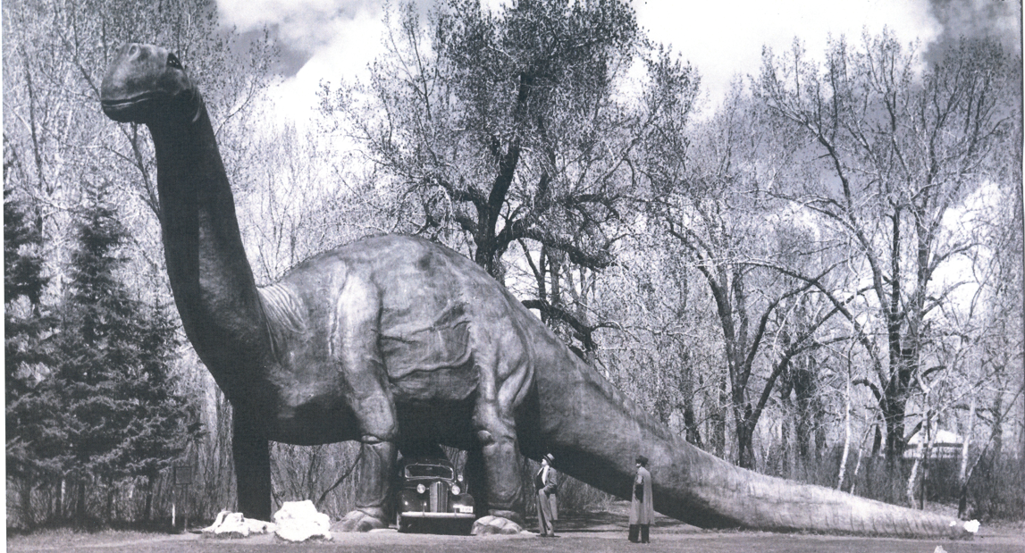

Dinosaurs in the Archives – Teacher’s Answer Key

The City of Calgary Archives has a wide variety of records about the arrival of the dinosaurs at the Calgary Zoo. Take a look at the records in the box to find the answers to the questions below…

- What date was the Natural History Park on St. George’s Island formally donated by the Calgary Zoological Society to The City of Calgary?
Aug. 25 1937 – The Calgary Herald
- Where did the idea to create a Dinosaur Garden come from? Why was the construction of this idea delayed until 1936?
In 1931 zoo director Lars Willumsen visited Hagenback Park Zoo in Germany and was overwhelmed with their dinosaur display. He returned to Calgary with a bold idea: Construct a prehistoric park at the St. George’s Island Zoo in Calgary. – City of Calgary Newsroom 20 March 2019
- How much money was approved by City Council for the development of the Dinosaur Garden? Why was construction delayed until 1936?
$50 000 = $1 Million Dollars today. Construction was delayed until the required funding could be raised – City Clerk’s Correspondence 1936
- How much was the builder paid to build the dinosaurs in 1935? Who were his helpers?
50c/hour His sons helped for free - Dinosaur Man Scrapbook
- What troubles did they experience when building the dinosaurs? What did they do to correct the problem? Do you think that this worked?
Vandalism. Fencing, Patrols and a Reward – City Clerk’s Correspondence 1937

- What were the first three dinosaurs to be built? Can you find photos of these dinosaurs? Do you think that these models would be considered accurate today?
Triceratops and two Caratosaurus – Parks Annual Report 1936 & Calgary Zoo Reference File
- How much does “Dinny” the dinosaur weigh? Is he hollow in the middle?
107 tons and is hollow in the middle – Parks Annual Report 1937
- Who created most of the dinosaurs? Who recommended that he be acknowledged at the Calgary Zoo?
Mr. John Kanerva, Mr. Minkinnett from the Bow View Nursing Home - City Clerk’s Correspondence 1969
- Which dinosaur was known as the “Thunder Lizard”? How did the “Thunder Lizard’s” environment protect it from predators?
Brontosaurus. Lakes and marshes were not accessible to predators- The Calgary Daily Herald, Aug 28, 1937
- What are the time periods and animals represented in the No. 1 Fossil House?
Paleozoic = Mollusks & Fish; Paleozoic = Amphibians; Mesozoic = Reptiles; Cenozoic = Mammals - The Honker 1955
- How did the builders know what the dinosaurs looked like when all we had to work from was bones?
The shape and size of muscles can be reconstructed by locating where the muscles were attached to the bones. There have been cases where the outline of the body has been preserved, and in other cases the skin texture has also been preserved - The Honker 1957
- When did “Dinny” become the Calgary Zoo’s official mascot?
1959 - Prehistoric Times 2006
- Why did Dinny need to be fixed in 2021? How much did this cost? Why did they create a “mini Dinny”?
A bum leg, stiff neck, and cracking in the concrete. $200k - $100k through fundraising. So that children will have a safe version for climbing - CTV News 29 June 2021
- Which dinosaur was the most photographed thing in Calgary for many years?
Dinny - CTV News June 19 2021
- Have you noticed that there are number of conflicting dates for when Dinny was created, how much he weighs and whether he was the first dinosaur to be built?? Which sources do you think are most reliable for this information? Why?
1935 vs 1937. Caratosaurus for the first dinosaur. Official city records created at the time of activity are the most reliable source – eg. Parks Annual Reports

